**RAJALAKSHMI ENGINEERING COLLEGE**

**RAJALAKSHMI NAGAR, THANDALAM – 602 105**



| **CS23332 DATABASE MANAGEMENT**  **SYSTEMS LAB** |
| --- |
|  |

Name :…………………………. ……………………………...

Year / Branch / Section : ……….. ……………………………….

University Register No. : …………….. ……………………………………

College Roll No. : …………………….……………………………………

Semester : ………………………………….………………………………………

Academic Year : ………………………………………………………….





**Definition of a Relational Database**

A relational database is a collection of relations or two-dimensional tables.

**Terminologies Used in a Relational Database**

1. A single ROW or table representing all data required for a particular employee. Each row should be identified by a primary key which allows no duplicate rows.

1. A COLUMN or attribute containing the employee number which identifies a unique employee. Here Employee number is designated as a primary key ,must contain a value and must be unique.

1. A column may contain foreign key. Here Dept_ID is a foreign key in employee table and it is a primary key in Department table.

1. A Field can be found at the intersection of a row and column. There can be only one value in it. Also it may have no value. This is called a null value.

| EMP ID | |  | FIRST NAME | | LAST NAME | | EMAIL | |
| --- | --- | --- | --- | --- | --- | --- | --- | --- |
| 100 |  |  | King | | Steven | | Sking | |
| 101 |  |  | John |  | Smith |  | Jsmith |  |
| 102 |  |  | Neena | | Bai | | Neenba | |
| 103 |  |  | Eex | | De Haan | | Ldehaan | |

**Relational Database Properties**

**A relational database :**

* Can be accessed and modified by executing structured query language (SQL) statements. ● Contains a collection of tables with no physical pointers.
* Uses a set of operators

**Relational Database Management Systems**

RDBMS refers to a relational database plus supporting software for managing users and processing [SQL](http://cplus.about.com/od/glossar1/g/sqldefinition.htm) queries, performing backups/restores and associated tasks.

(Relational Database Management System) Software for storing data using SQL (structured query language). A relational database uses SQL to store data in a series of tables that not only record existing relationships between data items, but which also permit the data to be joined in new relationships. SQL (pronounced 'sequel') is based on a system of algebra developed by E F Codd, an IBM scientist who first defined the relational model in 1970. Relational databases are optimized for storing transactional data, and the majority of modern business software applications therefore use an RDBMS as their data store. The leading RDBMS vendors are Oracle, IBM and Microsoft.

The first commercial RDBMS was the [Multics Relational Data Store,](http://dictionary.reference.com/browse/Multics+Relational+Data+Store) first sold in 1978. [INGRES,](http://dictionary.reference.com/browse/INGRES) [Oracle,](http://dictionary.reference.com/browse/Oracle) [Sybase, Inc.,](http://dictionary.reference.com/browse/Sybase,+Inc.) [Microsoft Access,](http://dictionary.reference.com/browse/Microsoft+Access) and [Microsoft SQL Server](http://dictionary.reference.com/browse/Microsoft+SQL+Server) are wellknown database products and companies.Others include [PostgreSQL,](http://dictionary.reference.com/browse/PostgreSQL) [SQL/DS,](http://dictionary.reference.com/browse/SQL/DS) and [RDB.](http://dictionary.reference.com/browse/RDB) A relational database management system (RDBMS) is a program that lets you create, update, and administer a [relational database.](http://whatis.techtarget.com/definition/0,289893,sid9_gci212885,00.html) Most commercial RDBMS's use the Structured Query Language [(SQL)](http://whatis.techtarget.com/definition/0,289893,sid9_gci214230,00.html) to access the database, although SQL was invented after the development of the relational model and is not necessary for its use.

The leading RDBMS products are [Oracle,](http://whatis.techtarget.com/definition/0,289893,sid9_gci214534,00.html) IBM's [DB2](http://whatis.techtarget.com/definition/0,289893,sid9_gci213553,00.html) and Microsoft's [SQL Server.](http://whatis.techtarget.com/definition/0,289893,sid9_gci1157492,00.html) Despite repeated challenges by competing technologies, as well as the claim by some experts that no current RDBMS has fully implemented relational principles, the majority of new corporate databases are still being created and managed with an RDBMS.

**SQL Statements**



1. Data Retrieval(DR)
2. Data Manipulation Language(DML)
3. Data Definition Language(DDL)
4. Data Control Language(DCL)
5. Transaction Control Language(TCL)

**TYPE** **STATEMENT** **DESCRIPTION** 

DR SELECT Retrieves the data from the database

DML 1.INSERT Enter new rows, changes existing rows, 2.UPDATE removes unwanted rows from tables in

3.DELETE the database respectively.

4.MERGE

DDL 1.CREATE Sets up, changes and removes data

2.ALTER structures from tables.

3.DROP

4.RENAME

5.TRUNCATE

TCL 1.COMMIT Manages the changes made by DML

2.ROLLBACK statements. Changes to the data can be

3.SAVEPOINT grouped together into logical transactions.

DCL 1.GRANT Gives or removes access rights to both 2.RREVOKE the oracle database and the structures within it.

**DATA TYPES**

1. **Character Data types:**

▪ Char – fixed length character string that can varies between 1-2000 bytes

▪ Varchar / Varchar2 – variable length character string, size ranges from 1-4000 bytes.it saves

the disk space(only length of the entered value will be assigned as the size of column) ▪ Long - variable length character string, maximum size is 2 GB

1. **Number Data types :** Can store +ve,-ve,zero,fixed point, floating point with 38 precission.

▪ Number – {p=38,s=0}

▪ Number(p) - fixed point

▪ Number(p,s) –floating point (p=1 to 38,s= -84 to 127)

1. **Date Time Data type:** used to store date and time in the table.

▪ DB uses its own format of storing in fixed length of 7 bytes for century, date, month, year, hour, minutes, and seconds.

▪ Default data type is “dd-mon-yy”

▪ New Date time data types have been introduced. They are

TIMESTAMP-Date with fractional seconds

INTERVAL YEAR TO MONTH-stored as an interval of years and months

INTERVAL DAY TO SECOND-stored as o interval of days to hour’s minutes and seconds

1. **Raw Data type:** used to store byte oriented data like binary data and byte string.

1. **Other :**

▪ CLOB – stores character object with single byte character.

▪ BLOB – stores large binary objects such as graphics, video, sounds.

▪ BFILE – stores file pointers to the LOB’s.

###### EXERCISE-1

###### Creating and Managing Tables

**OBJECTIVE**

After the completion of this exercise, students should be able to do the following:

⮚ Create tables

⮚ Describing the data types that can be used when specifying column definition

⮚ Alter table definitions

⮚ Drop, rename, and truncate tables

**NAMING RULES**

Table names and column names:

* Must begin with a letter
* Must be 1-30 characters long
* Must contain only A-Z, a-z, 0-9, _, $, and #
* Must not duplicate the name of another object owned by the same user ● Must not be an oracle server reserve words ● 2 different tables should not have same name.
* Should specify a unique column name.
* Should specify proper data type along with width
* Can include “not null” condition when needed. By default it is ‘null’.

**The CREATE TABLE Statement**

**Table:** Basic unit of storage; composed of rows and columns

**Syntax: 1** Create table table_name (column_name1 data_ type (size) column_name2 data_ type (size)….);

**Syntax: 2** Create table table_name (column_name1 data_ type (size) constraints, column_name2 data_ type constraints …); **Example:**

Create table employlees ( employee_id number(6), first_name varchar2(20), ..job_id varchar2(10),

CONSTRAINT emp_emp_id_pk PRIMARY KEY (employlee_id));

**Tables Used in this course**

**Creating a table by using a Sub query**

**SYNTAX**

// CREATE TABLE table_name(column_name type(size)…);

Create table table_name **as** select column_name1,column_name2,……colmn_namen from table_name where predicate;

**AS Subquery**

Subquery is the select statement that defines the set of rows to be inserted into the new table.

**Example**

Create table dept80 as select employee_id, last_name, salary*12 Annsal, hire_date from employees where dept_id=80;

**The ALTER TABLE Statement**

The ALTER statement is used to

* Add a new column
* Modify an existing column
* Define a default value to the new column ● Drop a column
* To include or drop integrity constraint.

**SYNTAX**

ALTER TABLE table_name ADD /MODIFY(Column_name type(size));

ALTER TABLE table_name DROP COLUMN (Column_nname);

*ALTER TABLE ADD CONSTRAINT Constraint_name PRIMARY KEY (Colum_Name);* **Example:**

Alter table dept80 add (jod_id varchar2(9));

Alter table dept80 modify (last_name varchar2(30));

Alter table dept80 drop column job_id;

**NOTE:** Once the column is dropped it cannot be recovered.

**DROPPING A TABLE**

* All data and structure in the table is deleted.
* Any pending transactions are committed.
* All indexes are dropped.
* Cannot roll back the drop table statement.

**Syntax:**

**Drop table *tablename;***

**Example:**

Drop table dept80;

**RENAMING A TABLE**

To rename a table or view.

**Syntax**

RENAME old_name to new_name

**Example:**

Rename dept to detail_dept;

**TRUNCATING A TABLE**

Removes all rows from the table.

Releases the storage space used by that table.

**Syntax**

TRUNCATE TABLE *table_name*; E**xample:**

TRUNCATE TABLE copy_emp;

**Find the Solution for the following:**

**Create the following tables with the given structure.**

**EMPLOYEES TABLE**

| **NAME** | **NULL?** | **TYPE** |
| --- | --- | --- |
| Employee_id | Not null | Number(6) |
| First_Name |  | Varchar(20) |
| Last_Name | Not null | Varchar(25) |
| Email | Not null | Varchar(25) |
| Phone_Number |  | Varchar(20) |
| Hire_date | Not null | Date |
| Job_id | Not null | Varchar(10) |
| Salary |  | Number(8,2) |
| Commission_pct |  | Number(2,2) |
| Manager_id |  | Number(6) |
| Department_id |  | Number(4) |

**DEPARTMENT TABLE**

| **NAME** | **NULL?** | **TYPE** |
| --- | --- | --- |
| Dept_id | Not null | Number(6) |
| Dept_name | Not null | Varchar(20) |
| Manager_id |  | Number(6) |
| Location_id |  | Number(4) |

**JOB_GRADE TABLE**

| **NAME** | **NULL?** | **TYPE** |
| --- | --- | --- |
| Grade_level |  | Varchar(2) |
| Lowest_sal |  | Number |
| Highest_sal |  | Number |

**LOCATION TABLE**

| **NAME** | **NULL?** | **TYPE** |
| --- | --- | --- |
| Location_id | Not null | Number(4) |
| St_addr |  | Varchar(40) |
| Postal_code |  | Varchar(12) |
| City | Not null | Varchar(30) |
| State_province |  | Varchar(25) |
| Country_id |  | Char(2) |

1. Create the DEPT table based on the DEPARTMENT following the table instance chart below. Confirm that the table is created.

| **Column name** | ID | NAME |
| --- | --- | --- |
| **Key Type** |  |  |
| **Nulls/Unique** |  |  |
| **FK table** |  |  |
| **FK column** |  |  |
| **Data Type** | Number | Varchar2 |
| **Length** | 7 | 25 |
| Create table dept(ID number(7),Name varchar2(25)); | | |

1. Create the EMP table based on the following instance chart. Confirm that the table is created.

| **Column name** | ID | LAST_NAME | FIRST_NAME | DEPT_ID |
| --- | --- | --- | --- | --- |
| **Key Type** |  |  |  |  |
| **Nulls/Unique** |  |  |  |  |
| **FK table** |  |  |  |  |
| **FK column** |  |  |  |  |
| **Data Type** | Number | Varchar2 | Varchar2 | Number |
| **Length** | 7 | 25 | 25 | 7 |
| create table em(ID number(7),first_name varchar2(25),last_name varchar2(25),dept_id  number(7)); | | | | |

1. Modify the EMP table to allow for longer employee last names. Confirm the modification.(Hint: Increase the size to 50)

| alter table em modify (last_name varchar2(50)); |
| --- |

1. Create the EMPLOYEES2 table based on the structure of EMPLOYEES table. Include Only the Employee_id, First_name, Last_name, Salary and Dept_id coloumns. Name the columns Id, First_name, Last_name, salary and Dept_id respectively.

| create table em2(ID number(7),first_name varchar2(25),last_name varchar2(25),Salary  number(20),dept_id number(7)); |
| --- |

1. Drop the EMP table.

| drop table em; |
| --- |

1. Rename the EMPLOYEES2 table as EMP.

| alter table em2 rename to employ; |
| --- |

1. Add a comment on DEPT and EMP tables. Confirm the modification by describing the table.

| comment on table dept is’This table stores id and name’;  select * from user_tab_comments;  select comments from user_tab_comments where table_name =’DEPT’ |
| --- |

1. Drop the First_name column from the EMP table and confirm it.

| alter table employ drop column first_name; |
| --- |

| Evaluation Procedure | Marks awarded |
| --- | --- |
| Query(5) |  |
| Execution (5) |  |
| Viva(5) |  |
| Total (15) |  |
| Faculty Signature |  |

###### EXERCISE-2

###### MANIPULATING DATA

**OBJECTIVE**

After, the completion of this exercise the students will be able to do the following

* Describe each DML statement
* Insert rows into tables
* Update rows into table
* Delete rows from table
* Control Transactions

A DML statement is executed when you:

* Add new rows to a table
* Modify existing rows
* Removing existing rows

A transaction consists of a collection of DML statements that form a logical unit of work.

**To Add a New Row**

INSERT Statement

**Syntax**

INSERT INTO table_name VALUES (column1 values, column2 values, …, columnn values);

**Example:**

INSERT INTO department (70, ‘Public relations’, 100,1700);

**Inserting rows with null values**

**Implicit Method:** (Omit the column)

INSERT INTO department VALUES (30,’purchasing’);

**Explicit Method:** (Specify NULL keyword)

INSERT INTO department VALUES (100,’finance’, NULL, NULL);

**Inserting Special Values**

**Example:**

Using SYSDATE

INSERT INTO employees VALUES (113,’louis’, ‘popp’, ‘lpopp’,’5151244567’,**SYSDATE**,

‘ac_account’, 6900, NULL, 205, 100);

**Inserting Specific Date Values** **Example:**

INSERT INTO employees VALUES ( 114,’den’, ‘raphealy’, ‘drapheal’, ‘5151274561’,

**TO_DATE(‘feb 3,1999’,’mon, dd ,yyyy’),** ‘ac_account’, 11000,100,30);

**To Insert Multiple Rows**

& is the placeholder for the variable value **Example:**

INSERT INTO department VALUES (&dept_id, &dept_name, &location);

**Copying Rows from another table**

⮚ Using Subquery **Example:**

INSER INTO sales_reps(id, name, salary, commission_pct)

SELECt employee_id, Last_name, salary, commission_pct

FROM employees

WHERE jod_id LIKE ‘%REP’);

**CHANGING DATA IN A TABLE**

UPDATE Statement

**Syntax1: (** to update specific rows**)**

UPDATE table_name SET column=value WHERE condition;

**Syntax 2:** (To updae all rows)

UPDATE table_name SET column=value;

**Updating columns with a subquery**

UPDATE employees

SET job_id= (SELECT job_id

FROM employees

WHERE employee_id=205)

WHERE employee_id=114;

**REMOVING A ROW FROM A TABLE**

**DELETE STATEMENT**

**Syntax**

DELETE FROM table_name WHERE conditions;

**Example:**

DELETE FROM department WHERE dept_name=’finance’’;

**Find the Solution for the following:**

1. Create MY_EMPLOYEE table with the following structure

| NAME | NULL? | TYPE |
| --- | --- | --- |
| ID | Not null | Number(4) |
| Last_name |  | Varchar(25) |
| First_name |  | Varchar(25) |
| Userid |  | Varchar(25) |
| Salary |  | Number(9,2) |

1. Add the first and second rows data to MY_EMPLOYEE table from the following sample data.

| **ID** | **Last_name** | **First_name** | **Userid** | **salary** |
| --- | --- | --- | --- | --- |
| 1 | Patel | Ralph | rpatel | 895 |
| 2 | Dancs | Betty | bdancs | 860 |
| 3 | Biri | Ben | bbiri | 1100 |
| 4 | Newman | Chad | Cnewman | 750 |
| 5 | Ropebur | Audrey | aropebur | 1550 |

1. Display the table with values.

| create table my_employee(ID number(4),last_name varchar(25),first_name varchar(25),userid varchar(25),Salary number(9,2));  insert into my_employee(ID,last_name,first_name,userid,Salary)values(1,'Patel','Ralph','rpatel',895);  insert into my_employee(Id,last_name,first_name,userid,Salary)values(2,'Dancs','betty','bdancs',860);  select * from my_employee; |
| --- |

1. Populate the next two rows of data from the sample data. Concatenate the first letter of the first_name with the first seven characters of the last_name to produce Userid.

| insert into my_employe(Id,last_name,first_name,userid,Salary)values(3,'biri','ben',substr('ben',1,1)||substr('biri',1,4),1100);  insert into my_employe(Id,last_name,first_name,userid,Salary)values(4,'newman','chad',substr('chad,1,1)||substr('newman',1,6),750); |
| --- |

1. Make the data additions permanent.

| commit; |
| --- |

1. Change the last name of employee 3 to Drexler.

| update my_employe set last_name='Drexler'where ID=3; |
| --- |

1. Change the salary to 1000 for all the employees with a salary less than 900.

| update my_employe set Salary=1000 where Salary<900; |
| --- |

1. Delete Betty dancs from MY _EMPLOYEE table.

| delete from my_employe where last_name='Dancs'; |
| --- |

1. Empty the fourth row of the emp table.

| update my_employe set last_name=NULL,first_name=NULL,userid=NULL,Salary=NULL where ID=4; |
| --- |

| Evaluation Procedure | Marks awarded |
| --- | --- |
| Query(5) |  |
| Execution (5) |  |
| Viva(5) |  |
| Total (15) |  |
| Faculty Signature |  |

###### EXERCISE-3

###### INCLUDING CONSTRAINTS

**OBJECTIVE**

After the completion of this exercise the students should be able to do the following

* Describe the constraints
* Create and maintain the constraints

**What are Integrity** **constraints?**

* Constraints enforce rules at the table level.
* Constraints prevent the deletion of a table if there are dependencies

**The following types of integrity constraints are valid**

a) **Domain Integrity**

* NOT NULL
* CHECK

b) **Entity Integrity**

* UNIQUE
* PRIMARY KEY

c)  **Referential Integrity**

✔ FOREIGN KEY

**Constraints can be created in either of two ways**

1. At the same time as the table is created
2. After the table has been created.

**Defining Constraints**

Create table tablename (column_name1 data_ type constraints, column_name2 data_ type constraints …);  **Example:**

Create table employlees ( employee_id number(6), first_name varchar2(20), ..job_id varchar2 (10),

CONSTRAINT emp_emp_id_pk PRIMARY KEY (employlee_id));

**Domain Integrity**

This constraint sets a range and any violations that takes place will prevent the user from performing the manipulation that caused the breach.It includes:

**NOT NULL Constraint**

While creating tables, by default the rows can have null value.the enforcement of not null constraint in a table ensure that the table contains values.

**Principle of null values:**

* Setting null value is appropriate when the actual value is unknown, or when a value would not be meaningful. o A null value is not equivalent to a value of zero. o A null value will always evaluate to null in any expression. o When a column name is defined as not null, that column becomes a mandatory i.e., the user has to enter data into it.
* Not null Integrity constraint cannot be defined using the alter table command when the table contain rows.

**Example**

CREATE TABLE employees (employee_id number (6), last_name varchar2(25) NOT NULL, salary number(8,2), commission_pct number(2,2), hire_date date constraint emp_hire_date_nn NOT NULL’….);

**CHECK**

Check constraint can be defined to allow only a particular range of values.when the manipulation violates this constraint,the record will be rejected.Check condition cannot contain sub queries.

CREATE TABLE employees (employee_id number (6), last_name varchar2 (25) NOT NULL, salary number(8,2), commission_pct number(2,2), hire_date date constraint emp_hire_date_nn NOT NULL’…,CONSTRAINT emp_salary_mi CHECK(salary > 0));

**Entity Integrity**

Maintains uniqueness in a record. An entity represents a table and each row of a table represents an instance of that entity. To identify each row in a table uniquely we need to use this constraint. There are 2 entity constraints:

**a) Unique key constraint**

It is used to ensure that information in the column for each record is unique, as with telephone or driver’s license numbers. It prevents the duplication of value with rows of a specified column in a set of column. A column defined with the constraint can allow null value.

If unique key constraint is defined in more than one column i.e., combination of column cannot be specified. Maximum combination of columns that a composite unique key can contain is 16.

**Example:**

CREATE TABLE employees (employee_id number(6), last_name varchar2(25) NOT NULL,email varchar2(25), salary number(8,2), commission_pct number(2,2), hire_date date constraint

emp_hire_date_nn NOT NULL’ COSTRAINT emp_email_uk UNIQUE(email));

**PRIMARY KEY CONSTRAINT**

A primary key avoids duplication of rows and does not allow null values. Can be defined on one or more columns in a table and is used to uniquely identify each row in a table. These values should never be changed and should never be null.

A table should have only one primary key. If a primary key constraint is assigned to more than one column or combination of column is said to be composite primary key, which can contain 16 columns.

**Example:**

CREATE TABLE employees (employee_id number(6) , last_name varchar2(25) NOT NULL,email varchar2(25), salary number(8,2), commission_pct number(2,2), hire_date date constraint emp_hire_date_nn NOT NULL, Constraint emp_id pk PRIMARY KEY

(employee_id),CONSTRAINT emp_email_uk UNIQUE(email));

**c) Referential Integrity**

It enforces relationship between tables. To establish parent-child relationship between 2 tables having a common column definition, we make use of this constraint. To implement this, we should define the column in the parent table as primary key and same column in the child table as foreign key referring to the corresponding parent entry.

**Foreign key**

A column or combination of column included in the definition of referential integrity, which would refer to a referenced key.

**Referenced key**

It is a unique or primary key upon which is defined on a column belonging to the parent table. Keywords:

**FOREIGN KEY:** Defines the column in the child table at the table level constraint.

**REFERENCES:** Identifies the table and column in the parent table.

**ON DELETE CASCADE:** Deletes the dependent rows in the child table when a row in the parent table is deleted.

**ON DELETE SET NULL:** converts dependent foreign key values to null when the parent value is removed.

CREATE TABLE employees (employee_id number(6) , last_name varchar2(25) NOT NULL,email varchar2(25), salary number(8,2), commission_pct number(2,2), hire_date date constraint emp_hire_date_nn NOT NULL, Constraint emp_id pk PRIMARY KEY (employee_id),CONSTRAINT emp_email_uk UNIQUE(email),CONSTRAINT emp_dept_fk

FOREIGN KEY (department_id) references deparments(dept_id));

**ADDING A CONSTRAINT**

Use the ALTER to

* Add or Drop a constraint, but not modify the structure
* Enable or Disable the constraints
* Add a not null constraint by using the Modify clause

**Syntax**

ALTER TABLE table name ADD CONSTRAINT Cons_name type(column name);

**Example:**

ALTER TABLE employees ADD CONSTRAINT emp_manager_fk FOREIGN KEY

(manager_id) REFERENCES employees (employee_id);

**DROPPING A CONSTRAINT**

**Example:**

ALTER TABLE employees DROP CONSTRAINT emp_manager_fk;

**CASCADE IN DROP**

* The CASCADE option of the DROP clause causes any dependent constraints also to be dropped.

**Syntax**

ALTER TABLE departments DROP PRIMARY KEY|UNIQUE (column)| CONSTRAINT constraint _name CASCADE;

**DISABLING CONSTRAINTS**

* Execute the DISABLE clause of the ALTER TABLE statement to deactivate an integrity constraint
* Apply the CASCADE option to disable dependent integrity constraints.

**Example**

ALTER TABLE employees DISABLE CONSTRAINT emp_emp_id_pk CASCADE;

**ENABLING CONSTRAINTS**

* Activate an integrity constraint currently disabled in the table definition by using the ENABLE clause.

**Example**

ALTER TABLE employees ENABLE CONSTRAINT emp_emp_id_pk CASCADE;

**CASCADING CONSTRAINTS**

The CASCADE CONSTRAINTS clause is used along with the DROP column clause.

It drops all referential integrity constraints that refer to the primary and unique keys defined on the dropped Columns.

This clause also drops all multicolumn constraints defined on the dropped column.

**Example:**

**Assume table TEST1 with the following structure**

CREATE TABLE test1 ( pk number PRIMARY KEY, fk number, col1 number,col2 number,

CONTRAINT fk_constraint FOREIGN KEY(fk) references test1, CONSTRAINT ck1 CHECK (pk>0 and col1>0), CONSTRAINT ck2 CHECK (col2>0));

**An error is returned for the following statements**

ALTER TABLE test1 DROP (pk);

ALTER TABLE test1 DROP (col1);

**The above statement can be written with CASCADE CONSTRAINT**

ALTER TABLE test 1 DROP(pk) CASCADE CONSTRAINTS;

**(OR)**

ALTER TABLE test 1 DROP(pk, fk, col1) CASCADE CONSTRAINTS;

**VIEWING CONSTRAINTS**

Query the USER_CONSTRAINTS table to view all the constraints definition and names.

**Example:**

SELECT constraint_name, constraint_type, search_condition FROM user_constraints

WHERE table_name=’employees’;

**Viewing the columns associated with constraints**

SELECT constraint_name, constraint_type, FROM user_cons_columns

WHERE table_name=’employees’;

**Find the Solution for the following:**

1. Add a table-level PRIMARY KEY constraint to the EMP table on the ID column.The constraint should be named at creation. Name the constraint my_emp_id_pk.

create table emp1(id number(5),first_name varchar2(20),last_name varchar2(10),constraint my_emp_id_pk primary key(id));

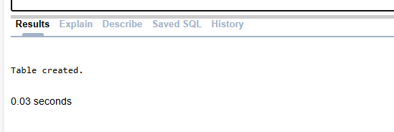

1. Create a PRIMAY KEY constraint to the DEPT table using the ID colum. The constraint should be named at creation. Name the constraint my_dept_id_pk.

create table depart(id number(10),dept_name varchar2(20),constraint my_dept_id_pk primary key(id));

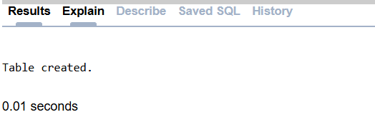

1. Add a column DEPT_ID to the EMP table. Add a foreign key reference on the EMP table that ensures that the employee is not assigned to nonexistent deparment. Name the constraint my_emp_dept_id_fk.

alter table emp1 add dept_id number(25);

alter table emp1 add constraint my_emp_dept_id_fk foreign key(dept_id) references depart(id);

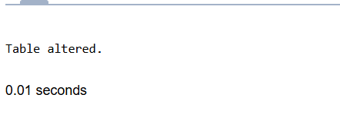

1. Modify the EMP table. Add a COMMISSION column of NUMBER data type, precision 2, scale 2. Add a constraint to the commission column that ensures that a commission value is greater than zero.

alter table emp1 add commission number(2,2);

alter table emp1 add constraint commission_check check(commission>0);

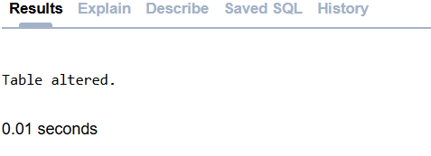

| Evaluation Procedure | Marks awarded |
| --- | --- |
| Query(5) |  |
| Execution (5) |  |
| Viva(5) |  |
| Total (15) |  |
| Faculty Signature |  |

###### EXERCISE-4

###### Writing Basic SQL SELECT Statements

**OBJECTIVES**

After the completion of this exercise, the students will be able to do the following:

* List the capabilities of SQL SELECT Statement
* Execute a basic SELECT statement

**Capabilities of SQL SELECT statement**

A SELECT statement retrieves information from the database. Using a select statement, we can perform

* Projection: To choose the columns in a table
* Selection: To choose the rows in a table
* Joining: To bring together the data that is stored in different tables

**Basic SELECT Statement**

**Syntax**

SELECT *|DISTINCT Column_ name| alias

` FROM table_name; **NOTE:**

DISTINCT—Suppr ess the duplicates.

Alias—gives selected columns different headings.

**Example: 1**

SELECT * FROM departments;

**Example: 2**

SELECT location_id, department_id FROM departments;

**Writing SQL Statements**

* SQL statements are not case sensitive ● SQL statements can be on one or more lines.
* Keywords cannot be abbreviated or split across lines
* Clauses are usually placed on separate lines
* Indents are sued to enhance readability

**Using Arithmetic Expressions**

Basic Arithmetic operators like *, /, +, -can be used

**Example:1**

SELECT last_name, salary, salary+300 FROM employees;

**Example:2**

SELECT last_name, salary, 12*salary+100 FROM employees;

The statement is not same as

SELECT last_name, salary, 12*(salary+100) FROM employees;

**Example:3**

SELECT last_name, job_id, salary, commission_pct FROM employees;

**Example:4**

SELECT last_name, job_id, salary, 12*salary*commission_pct FROM employees;

**Using Column Alias**

* To rename a column heading with or without AS keyword.

**Example:1**

SELECT last_name AS Name

FROM employees;

**Example: 2**

SELECT last_name “Name” salary*12 “Annual Salary “

FROM employees;

**Concatenation Operator**

* Concatenates columns or character strings to other columns
* Represented by two vertical bars (||)
* Creates a resultant column that is a character expression **Example:**

SELECT last_name||job_id AS “EMPLOYEES JOB” FROM employees;

**Using Literal Character String**

* A literal is a character, a number, or a date included in the SELECT list.
* Date and character literal values must be enclosed within single quotation marks.

**Example:**

SELECT last_name||’is a’||job_id AS “EMPLOYEES JOB” FROM employees;

**Eliminating Duplicate Rows**

* Using DISTINCT keyword.

**Example:**

SELECT DISTINCT deparment_id FROM employees;

**Displaying Table Structure**

* Using DESC keyword.

**Syntax** DESC table_name; **Example:**

DESC employees;

**Find the Solution for the following:**

**True OR False**

1. The following statement executes successfully.

**Identify the Errors**

SELECT employee_id, last_name sal*12 ANNUAL SALARY

FROM employees;

**Queries**

select employee_id,last_name,sal*12 as “annual salary” from employees;

1. Show the structure of departments the table. Select all the data from it.

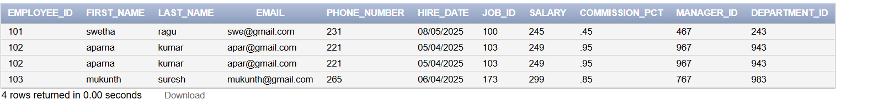

1. Create a query to display the last name, job code, hire date, and employee number for each employee, with employee number appearing first.

select employee_id,last_name,job_id,hire_date from employees;

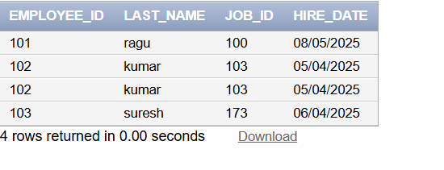

1. Provide an alias STARTDATE for the hire date.

select hire_date as STARTDATE from employees;

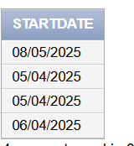

1. Create a query to display unique job codes from the employee table.

select distinct job_id from employees;

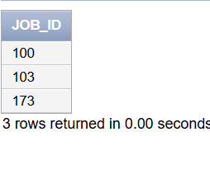

1. Display the last name concatenated with the job ID , separated by a comma and space, and name the column EMPLOYEE and TITLE.

select last_name||','||job_id as "employee and title" from employees;

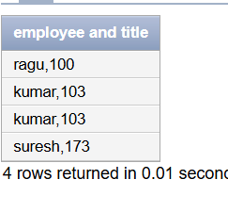

1. Create a query to display all the data from the employees table. Separate each column by a comma. Name the column THE_OUTPUT.

select employee_id||','||first_name||','||last_name||','||email||','||phone_number||','||hire_date||','||job_id||','||salary||','||commission_pct||','||manager_id||','||department_id as "the output" from employees;

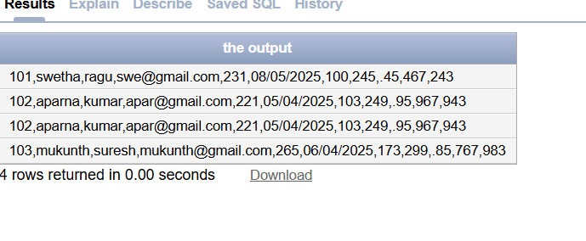

| Evaluation Procedure | Marks awarded |
| --- | --- |
| Query(5) |  |
| Execution (5) |  |
| Viva(5) |  |
| Total (15) |  |
| Faculty Signature |  |

###### EXERCISE-5

###### Restricting and Sorting data

After the completion of this exercise, the students will be able to do the following:

* Limit the rows retrieved by the queries
* Sort the rows retrieved by the queries

**Limiting the Rows selected**

* Using WHERE clause
* Alias cannot used in WHERE clause

**Syntax**

SELECT----------

FROM---------- WHERE condition; **Example:**

SELECT employee_id,last_name, job_id, deparment_id FROM employees WHERE department_id=90;

**Character strings and Dates**

Character strings and date values are enclosed in single quotation marks.

Character values are case sensitive and date values are format sensitive.

**Example:**

SELECT employee_id,last_name, job_id, deparment_id FROM employees

WHERE last_name=’WHALEN”;

**Comparison Conditions**

All relational operators can be used. (=, >, >=, <, <= ,<>,!=)

**Example:**

SELECT last_name, salary

FROM employees

WHERE salary<=3000;

**Other comparison conditions**

| Operator | Meaning |
| --- | --- |
| BETWEEN  …AND… | Between two values |
| IN | Match any of a list of values |
| LIKE | Match a character pattern |
| IS NULL | Is a null values |

**Example:1**

SELECT last_name, salary

FROM employees

WHERE salary BETWEEN 2500 AND 3500;

**Example:2**

SELECT employee_id, last_name, salary , manager_id

FROM employees

WHERE manager_id IN (101, 100,201);

**Example:3**

* Use the LIKE condition to perform wildcard searches of valid string values.
* Two symbols can be used to construct the search string

▪ % denotes zero or more characters

▪ _ denotes one character

SELECT first_name, salary

FROM employees

WHERE first_name LIKE ‘%s’;

**Example:4**

SELECT last_name, salary FROM employees

WHERE last_name LIKE ‘_o%’;

**Example:5**

**ESCAPE option**-To have an exact match for the actual % and_ characters

To search for the string that contain ‘SA_’

SELECT employee_id, first_name, salary,job_id FROM employees

WHERE job_id LIKE ‘%sa\_%’ESCAPE’\’;

**Test for NULL**

● Using IS NULL operator **Example:**

SELECT employee_id, last_name, salary , manager_id

FROM employees

WHERE manager_id IS NULL;

**Logical Conditions**

All logical operators can be used.( AND,OR,NOT)

**Example:1**

SELECT employee_id, last_name, salary , job_id

FROM employees

WHERE salary>=10000

AND job_id LIKE ‘%MAN%’;

**Example:2**

SELECT employee_id, last_name, salary , job_id

FROM employees

WHERE salary>=10000

OR job_id LIKE ‘%MAN%’;

**Example:3**

SELECT employee_id, last_name, salary , job_id FROM employees

WHERE job_id NOT IN (‘it_prog’, st_clerk’, sa_rep’);

**Rules of Precedence**

| **Order**  **Evaluated** | **Operator** |
| --- | --- |
| 1 | Arithmetic |
| 2 | Concatenation |
| 3 | Comparison |
| 4 | IS [NOT] NULL, LIKE, [NOT] IN |
| 5 | [NOT] BETWEEN |
| 6 | Logical NOT |
| 7 | Logical AND |
| 8 | Logical OR |

**Example:1**

SELECT employee_id, last_name, salary , job_id

FROM employees WHERE job_id =’sa_rep’

OR job_id=’ad_pres’

AND salary>15000;

**Example:2**

SELECT employee_id, last_name, salary , job_id

FROM employees WHERE (job_id =’sa_rep’

OR job_id=’ad_pres’)

AND salary>15000;

**Sorting the rows**

Using ORDER BY Clause

**ASC**-Ascending Order,Default

**DESC**-Descending order

**Example:1**

SELECT last_name, salary , job_id,department_id,hire_date

FROM employees

ORDER BY hire_date;

**Example:2**

SELECT last_name, salary , job_id,department_id,hire_date

FROM employees

ORDER BY hire_date DESC;

**Example:3**

**Sorting by column alias**

SELECT last_name, salary*12 annsal , job_id,department_id,hire_date

FROM employees

ORDER BY annsal;

**Example:4**

**Sorting by Multiple columns**

SELECT last_name, salary , job_id,department_id,hire_date

FROM employees

ORDER BY department_id, salary DESC;

**Find the Solution for the following:**

1. Create a query to display the last name and salary of employees earning more than 12000.

select last_name,salary from employee where salary>12000;

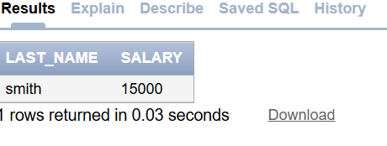

1. Create a query to display the employee last name and department number for employee number 176.

select last_name,department_id from employee where employee_id=176;

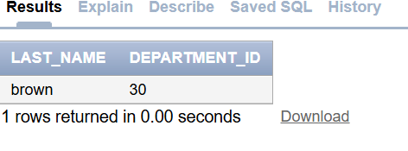

1. Create a query to display the last name and salary of employees whose salary is not in the range of 5000 and 12000. (hints: not between )

select last_name,salary from employee where salary not between 5000 and 12000;

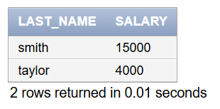

1. Display the employee last name, job ID, and start date of employees hired between

February 20,1998 and May 1,1998.order the query in ascending order by start date.(hints: between)

select last_name,job_id,hire_date from employee where hire_date between 02/20/1998 and 05/01/1998 order by hire_date asc;

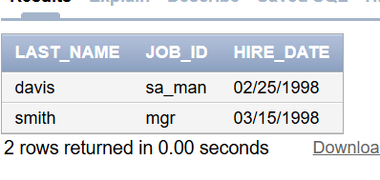

1. Display the last name and department number of all employees in departments 20 and 50 in alphabetical order by name.(hints: in, orderby)

select last_name,department_id from employee where department_id in(20,50) order by last_name asc;

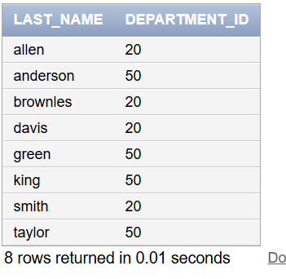

1. Display the last name and salary of all employees who earn between 5000 and 12000 and are in departments 20 and 50 in alphabetical order by name. Label the columns EMPLOYEE, MONTHLY SALARY respectively.(hints: between, in)

select last_name as "employee",salary as "monthly salary" from employee where salary between 5000 and 12000 and department_id in(20,50) order by last_name asc;

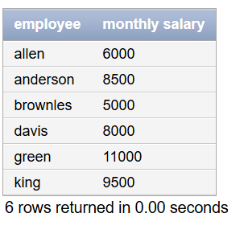

1. Display the last name and hire date of every employee who was hired in 1994.(hints: like)

select last_name,hire_date from employee where hire_date like '%1994';

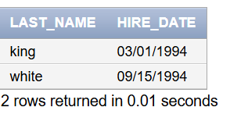

1. Display the last name and job title of all employees who do not have a manager.(hints: is null)

select last_name,job_id from employee where manager_id is null;

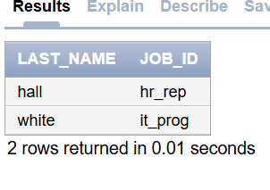

1. Display the last name, salary, and commission for all employees who earn commissions. Sort data in descending order of salary and commissions.(hints: is not nul,orderby)

select last_name,salary,commision_pct from employee where commision_pct is not null order by salary,commision_pct desc;

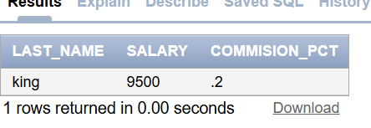

1. Display the last name of all employees where the third letter of the name is ***a***.(hints:like)

select last_name from employee where last_name like ' a%';

1. Display the last name of all employees who have an a and an ***e*** in their last name.(hints:

like)

select last_name from employee where last_name like '%a%%e%';

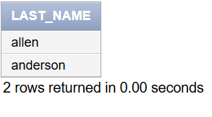

1. Display the last name and job and salary for all employees whose job is sales representative or stock clerk and whose salary is not equal to 2500 ,3500 or 7000.(hints:in,not in)

select last_name,job_id,salary from employee where job_id='sarep' or job_id='st_clerk' and salary not in(2500,3500,7000);

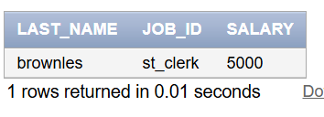

1. Display the last name, salary, and commission for all employees whose commission amount is 20%.(hints:use predicate logic)

select last_name,salary,commision_pct from employee where commision_pct=0.2;

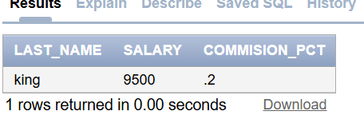

| Evaluation Procedure | Marks awarded |
| --- | --- |
| Query(5) |  |
| Execution (5) |  |
| Viva(5) |  |
| Total (15) |  |
| Faculty Signature |  |

**EXERCISE-6**

**Single Row Functions**

**Objective**

| Evaluation Procedure | Marks awarded |
| --- | --- |
| Practice Evaluation (5) |  |
| Viva(5) |  |
| Total (10) |  |
| Faculty Signature |  |

After the completion of this exercise, the students will be able to do the following:

* Describe various types of functions available in SQL.
* Use character, number and date functions in SELECT statement.
* Describe the use of conversion functions.

**Single row functions:**

Manipulate data items.

Accept arguments and return one value.

Act on each row returned.

Return one result per row.

May modify the data type.

Can be nested.

Accept arguments which can be a column or an expression

**Syntax**

Function_name(arg1,…argn)

An argument can be one of the following

* User-supplied constant
* Variable value
* Column name
* Expression



* Character Functions: Accept character input and can return both character and number values.
* Number functions: Accept numeric input and return numeric values.
* Date Functions: Operate on values of the DATE data type.
* Conversion Functions: Convert a value from one type to another.

**Character Functions**

Character Functions



Case-manipulation functions Character-manipulation functions

1. Lower 1. Concat
2. Upper 2. Substr
3. Initcap 3. Length
4. Instr
5. Lpad/Rpad
6. Trim
7. Repalce

| **Function** | **Purpose** |
| --- | --- |
| lower(column/expr) | Converts alpha character values to lowercase |
| upper(column/expr) | Converts alpha character values to uppercase |
| initcap(column/expr) | Converts alpha character values the to uppercase for the first letter of each word, all other letters in lowercase |
| concat(column1/expr1, column2/expr2) | Concatenates the first character to the second character |
| substr(column/expr,m,n) | Returns specified characters from character value starting at character position m, n characters long |
| length(column/expr) | Returns the number of characters in the expression |
| instr(column/expr,’string’,m,n) | Returns the numeric position of a named string |
| lpad(column/expr, n,’string’) | Pads the character value right-justified to a total width of n character positions |
| rpad(column/expr,’string’,m,n) | Pads the character value left-justified to a total width of n character positions |
| trim(leading/trailing/both, trim_character FROM trim_source) | Enables you to trim heading or string. trailing or both from a character |
| replace(text, search_string, replacement_string) |  |

**Example:**

lower(‘SQL Course’)🡪sql course upper(‘SQL Course’)🡪SQL COURSE

initcap(‘SQL Course’)🡪Sql Course

SELECT ‘The job id for’|| upper(last_name||’is’||lower(job_id) AS “EMPLOYEE DETAILS” FROM employees;

SELECT employee_id, last_name, department_id FROM employees

WHERE LOWER(last_name)=’higgins’;

| **Function** | **Result** |
| --- | --- |
| CONCAT(‘hello’, ‘world’) | helloworld |
| Substr(‘helloworld’,1,5) | Hello |
| Length(‘helloworld’) | 10 |
| Instr(‘helloworld’,’w’) | 6 |
| Lpad(salary,10,’*’) | *****24000 |
| Rpad(salary,10,’*’) | 24000***** |
| Trim(‘h’ FROM ‘helloworld’) | elloworld |

| **Command** | **Query** | **Output** |
| --- | --- | --- |
| initcap(char); | *select initcap(“hello”) from dual;* | Hello |
| lower (char); upper (char); | *select lower (‘HELLO’) from dual;* *select upper (‘hello’) from dual;* | Hello  HELLO |
| ltrim (char,[set]); | *select ltrim (‘cseit’, ‘cse’) from dual;* | IT |
| rtrim (char,[set]); | *select rtrim (‘cseit’, ‘it’) from dual;* | CSE |
| replace (char,search string, replace string); | *select replace (‘jack and jue’, ‘j’, ‘bl’) from dual;* | black and blue |
| substr (char,m,n); | *select substr (‘information’, 3, 4) from dual;* | form |

**Example:**

SELECT employee_id, CONCAT (first_name,last_name) NAME , job_id,LENGTH(last_name),

INSTR(last_name,’a’) “contains’a’?”

FROM employees WHERE SUBSTR(job_id,4)=’ERP’;

**NUMBER FUNCTIONS**

| **Function** | **Purpose** |
| --- | --- |
| round(column/expr, n) | Rounds the value to specified decimal |
| trunc(column/expr,n) | Truncates value to specified decimal |
| mod(m,n) | Returns remainder of division |

**Example**

| Function | Result |
| --- | --- |
| round(45.926,2) | 45.93 |
| trunc(45.926,2) | 45.92 |
| mod(1600,300) | 100 |

SELECT ROUND(45.923,2), ROUND(45.923,0), ROUND(45.923,-1) FROM dual;

**NOTE:**  Dual is a dummy table you can use to view results from functions and calculations.

SELECT TRUNC(45.923,2), TRUNC(45.923), TRUNC(45.923,-2) FROM dual;

SELECT last_name,salary,MOD(salary,5000) FROM employees WHERE job_id=’sa_rep’; **Working with Dates**

The Oracle database stores dates in an internal numeric format: century, year, month, day, hours, minutes, and seconds.

• The default date display format is DD-MON-RR.

* Enables you to store 21st-century dates in the 20th century by specifying only the last two digits of the year
* Enables you to store 20th-century dates in the 21st century in the same way **Example**

SELECT last_name, hire_date FROM employees WHERE hire_date < '01-FEB-88;

**Working with Dates**

SYSDATE is a function that returns:

* Date
* Time

**Example**

**Display the current date using the DUAL table.**

SELECT SYSDATE FROM DUAL;

**Arithmetic with Dates**

* Add or subtract a number to or from a date for a resultant date value.
* Subtract two dates to find the number of days between those dates.
* Add hours to a date by dividing the number of hours by 24.

**Arithmetic with Dates**

Because the database stores dates as numbers, you can perform calculations using arithmetic Operators such as addition and subtraction. You can add and subtract number constants as well as dates.

You can perform the following operations:

| **Operation** | **Result** |  | **Description** |
| --- | --- | --- | --- |
| date + number | Date |  | Adds a number of days to a date |
| date – number | Date |  | Subtracts a number of days from a date |
| date – date | Number of days |  | Subtracts one date from another |
| date + number/24 | Date |  | Adds a number of hours to a date |

**Example**

SELECT last_name, (SYSDATE-hire_date)/7 AS WEEKS

FROM employees

WHERE department_id = 90;

**Date Functions**

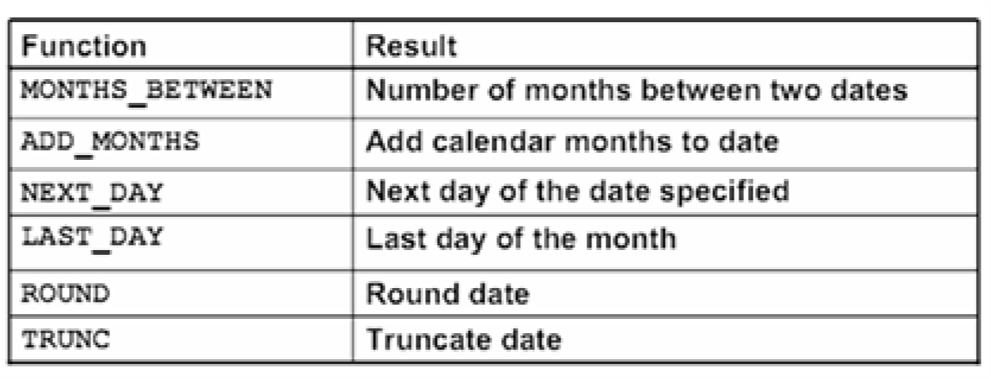

**Date Functions**

Date functions operate on Oracle dates. All date functions return a value of DATE data type except MONTHS_BETWEEN, which returns a numeric value.

* MONTHS_BETWEEN(date1, date2)::: Finds the number of months between date1 and date2. The result can be positive or negative. If date1 is later than date2, the result is positive; if date1 is earlier than date2, the result is negative. The noninteger part of the result represents a portion of the month.

* ADD_MONTHS(date, n)::: Adds n number of calendar months to date. The value of n must be an integer and can be negative.

* NEXT_DAY(date, 'char')::: Finds the date of the next specified day of the week ('char') following date. The value of char may be a number representing a day or a character string.

* LAST_DAY(date)::: Finds the date of the last day of the month that contains date
* ROUND(date[,'fmt'])::: Returns date rounded to the unit that is specified by the format model fmt. If the format model fmt is omitted, date is rounded to the nearest day.

* TRUNC(date[, 'fmt'])::: Returns date with the time portion of the day truncated to the unit that is specified by the format model fmt. If the format model fmt is omitted, date is truncated to the nearest day.

**Using Date Functions**

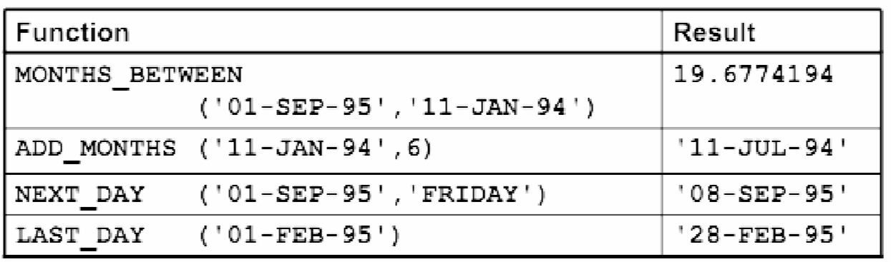

**Example**

Display the employee number, hire date, number of months employed, sixmonth review date, first Friday after hire date, and last day of the hire month for all employees who have been employed for fewer than 70 months.

SELECT employee_id, hire_date,MONTHS_BETWEEN (SYSDATE, hire_date)

TENURE,ADD_MONTHS (hire_date, 6) REVIEW,NEXT_DAY (hire_date, 'FRIDAY'),

LAST_DAY(hire_date)

FROM employees

WHERE MONTHS_BETWEEN (SYSDATE, hire_date) < 70;

**Conversion Functions**

This covers the following topics:

* Writing a query that displays the current date
* Creating queries that require the use of numeric, character, and date functions
* Performing calculations of years and months of service for an employee

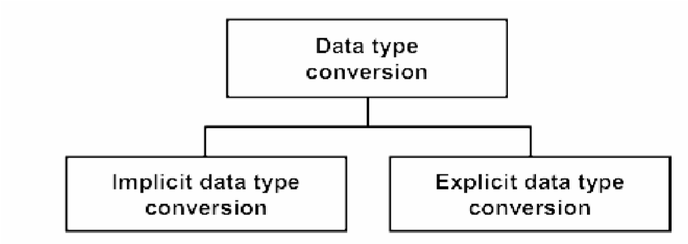

**Implicit Data Type Conversion**

For assignments, the Oracle server can automatically convert the following:

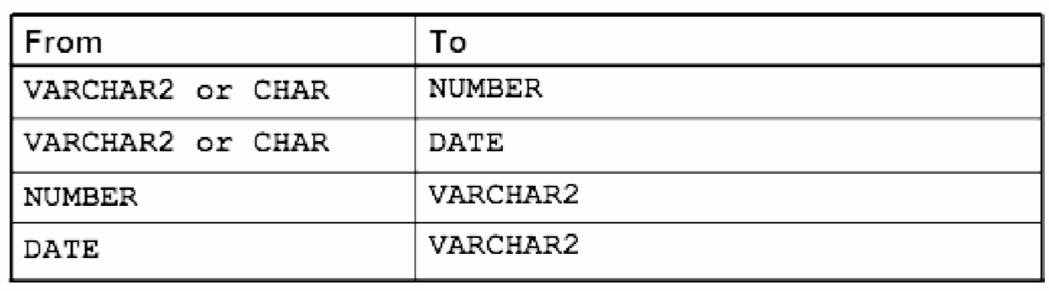

For example, the expression hire_date > '01-JAN-90' results in the implicit conversion from the string '01-JAN-90' to a date.

For expression evaluation, the Oracle Server can automatically convert the following:



**SQL provides three functions to convert a value from one data type to another:**

**Example:**

**Using the TO_CHAR Function with Dates** TO_CHAR(date, 'format_model') **The format model:**

* Must be enclosed by single quotation marks
* Is case-sensitive
* Can include any valid date format element
* Has an fm element to remove padded blanks or suppress leading zeros
* Is separated from the date value by a comma

SELECT employee_id, TO_CHAR(hire_date, 'MM/YY') Month_Hired

FROM employees WHERE last_name = 'Higgins';



**Date Format Elements:** Time Formats

Use the formats that are listed in the following tables to display time information and literals and to change numerals to spelled numbers.

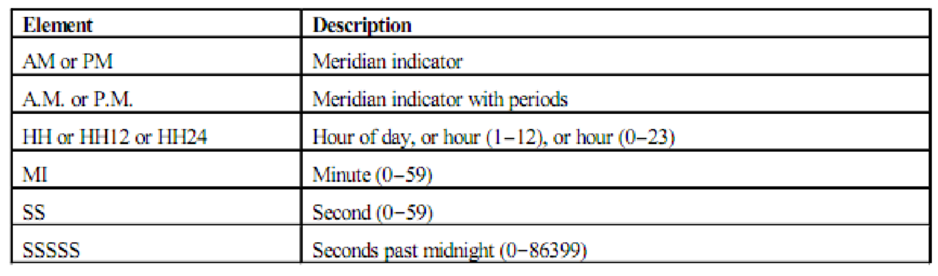

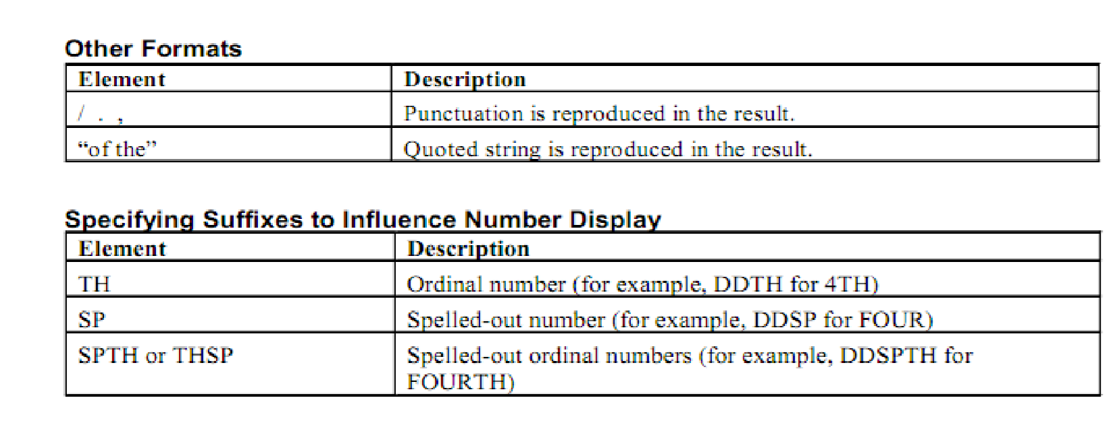

**Example**

SELECT last_name,

TO_CHAR(hire_date, 'fmDD Month YYYY') AS HIREDATE

FROM employees;

Modify example to display the dates in a format that appears as “Seventeenth of June 1987

12:00:00 AM.”

SELECT last_name,

TO_CHAR (hire_date, 'fmDdspth "of" Month YYYY fmHH:MI:SS AM') HIREDATE

FROM employees;

**Using the TO_CHAR Function with Numbers**

TO_CHAR(number, 'format_model')

These are some of the format elements that you can use with the TO_CHAR function to display a number value as a character:

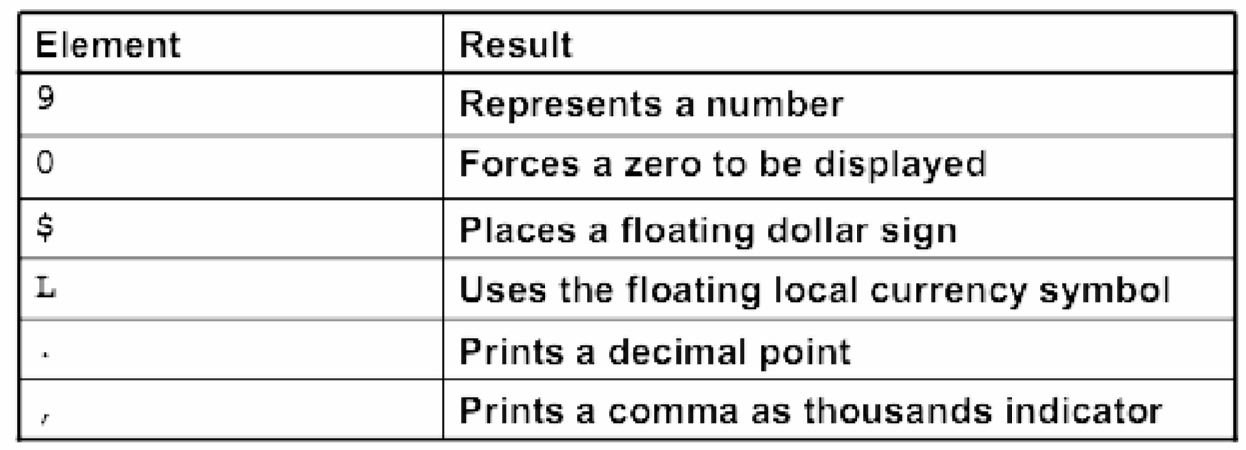

**Number Format Elements**

If you are converting a number to the character data type, you can use the following format elements:

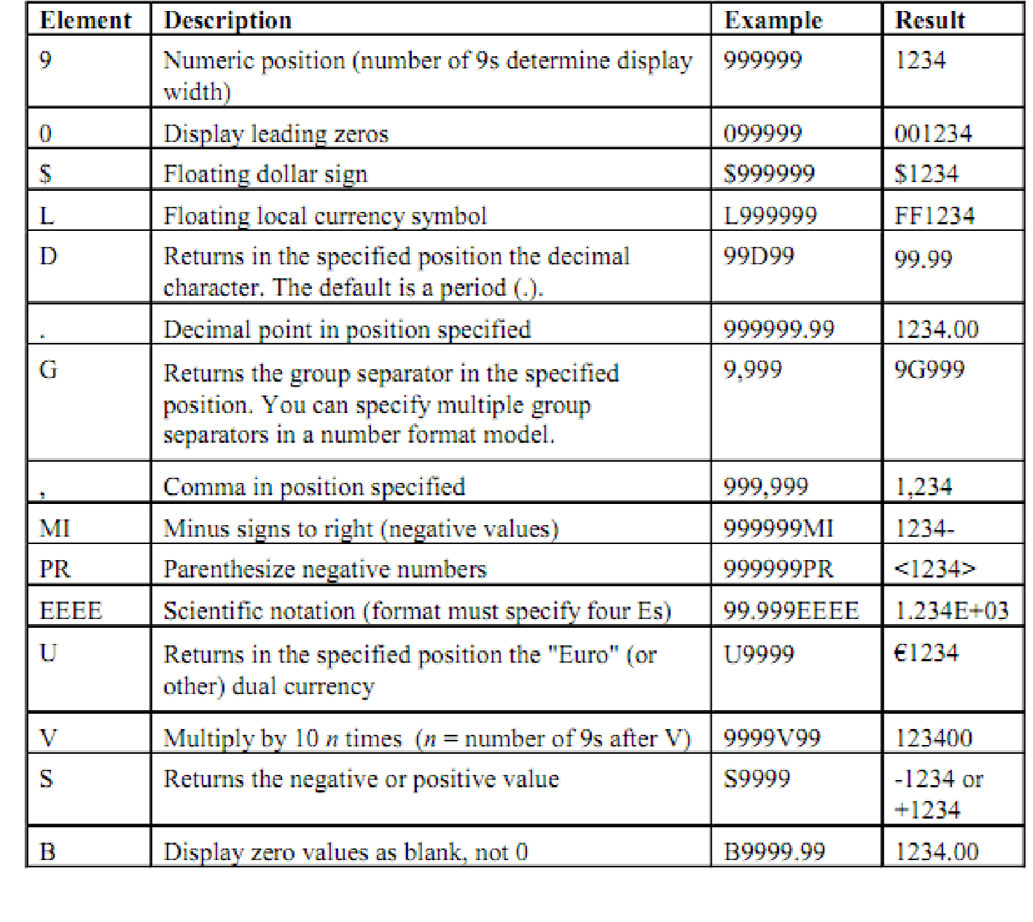

SELECT TO_CHAR(salary, '$99,999.00') SALARY

FROM employees

WHERE last_name = 'Ernst';

**Using the TO_NUMBER and TO_DATE Functions**

* Convert a character string to a number format using the TO_NUMBER function:

TO_NUMBER(char[, 'format_model']

* Convert a character string to a date format using the TO_DATE function:

TO_DATE(char[, 'format_model']

* These functions have an fx modifier. This modifier specifies the exact matching for the character argument and date format model of a TO_DATE function.

The fx modifier specifies exact matching for the character argument and date format model of a TO_DATE function:

* Punctuation and quoted text in the character argument must exactly match (except for case) the corresponding parts of the format model.

* The character argument cannot have extra blanks. Without fx, Oracle ignores extra blanks.

* Numeric data in the character argument must have the same number of digits as the corresponding element in the format model. Without fx, numbers in the character argument can omit leading zeros.

SELECT last_name, hire_date

FROM employees

WHERE hire_date = TO_DATE('May 24, 1999', 'fxMonth DD, YYYY');

**Find the Solution for the following:**

1. Write a query to display the current date. Label the column Date.

select sysdate as "Date" from dual;

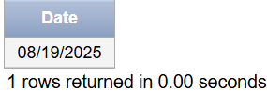

1. The HR department needs a report to display the employee number, last name, salary, and increased by 15.5% (expressed as a whole number) for each employee. Label the column New Salary.

select emp_id,last_name,round(salary+salary*0.155) as "New salary" from emp1;

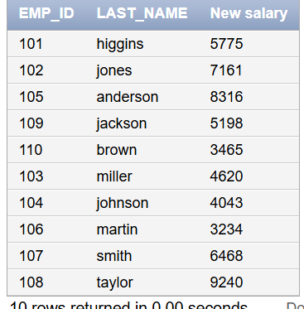

1. Modify your query lab_03_02.sql to add a column that subtracts the old salary from the new salary. Label the column Increase.

alter table emp1 add increase number(10,2);

update emp1 set increase= salary *0.155;

1. Write a query that displays the last name (with the first letter uppercase and all other letters lowercase) and the length of the last name for all employees whose name starts with the letters J, A, or M. Give each column an appropriate label. Sort the results by the employees’ last names.

select initcap(last_name) as "Last Name",length(last_name) as "Name length" from emp1 where upper(substr(last_name,1,1)) in ('J','A','M') order by last_name;

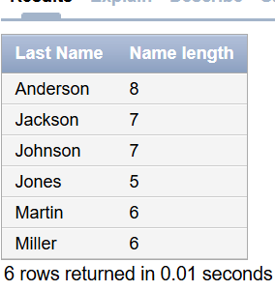

1. Rewrite the query so that the user is prompted to enter a letter that starts the last name. For example, if the user enters H when prompted for a letter, then the output should show all employees whose last name starts with the letter H.

initcap(last_name) as "Last Name",length(last_name) as "Name length" from emp1 where upper(substr(last_name,1,1))=upper('&letter') order by last_name;

1. The HR department wants to find the length of employment for each employee. For each employee, display the last name and calculate the number of months between today and the date on which the employee was hired. Label the column MONTHS_WORKED. Order your results by the number of months employed. Round the number of months up to the closest whole number.

select last_name,round(months_between(sysdate,hire_date)) as "MONTHS_WORKED" from emp1 order by MONTHS_WORKED;

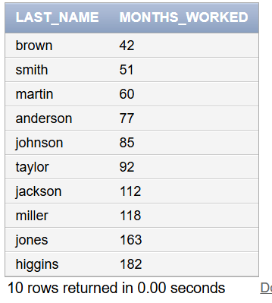

**Note:** Your results will differ.

1. Create a report that produces the following for each employee:

<employee last name> earns <salary> monthly but wants <3 times salary>. Label the column Dream Salaries.

select last_name||'earns'||salary||'monthly but wants'||(salary*3) as "Dream salaries" from emp1;

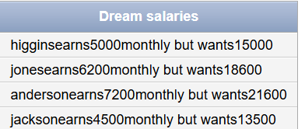

1. Create a query to display the last name and salary for all employees. Format the salary to be 15 characters long, left-padded with the $ symbol. Label the column SALARY.

select last_name,lpad(salary,15,'$') as "SALARY" from emp1;

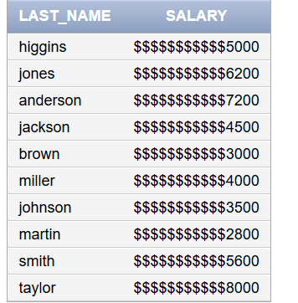

1. Display each employee’s last name, hire date, and salary review date, which is the first Monday after six months of service. Label the column REVIEW. Format the dates to appear in the format similar to “Monday, the Thirty-First of July, 2000.”

select last_name,to_char(hire_date,'Day,"the" ddspth "of" month,YYYY')as "Hire Date",to_char(next_day(add_months(hire_date,6),'Monday'),'Day,"the",Ddspth "of" Month,YYYY')as REVIEW from emp1;

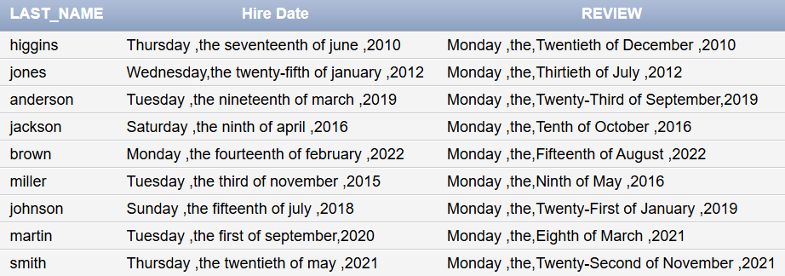

1. Display the last name, hire date, and day of the week on which the employee started. Label the column DAY. Order the results by the day of the week, starting with Monday.

select last_name,hire_date,to_char(hire_date,'Day') as"DAY" from emp1 order by to_char(hire_date,'D');

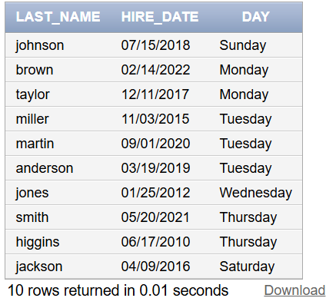

| Evaluation Procedure | Marks awarded |
| --- | --- |
| Query(5) |  |
| Execution (5) |  |
| Viva(5) |  |
| Total (15) |  |
| Faculty Signature |  |

###### EXERCISE-7

###### Displaying data from multiple tables

**Objective**

After the completion of this exercise, the students will be able to do the following:

* Write SELECT statements to access data from more than one table using equality and nonequality joins
* View data that generally does not meet a join condition by using outer joins
* Join a table to itself by using a self join

Sometimes you need to use data from more than one table.

**Cartesian Products**

* A Cartesian product is formed when:
* A join condition is omitted
* A join condition is invalid
* All rows in the first table are joined to all rows in the second table

• To avoid a Cartesian product, always include a valid join condition in a WHERE clause.

A Cartesian product tends to generate a large number of rows, and the result is rarely useful. You should always include a valid join condition in a WHERE clause, unless you have a specific need to combine all rows from all tables.

Cartesian products are useful for some tests when you need to generate a large number of rows to simulate a reasonable amount of data.

**Example:**

To displays employee last name and department name from the EMPLOYEES and DEPARTMENTS tables.

SELECT last_name, department_name dept_name

FROM employees, departments;

**Types of Joins**

* Equijoin
* Non-equijoin
* Outer join
* Self join
* Cross joins
* Natural joins
* Using clause
* Full or two sided outer joins
* Arbitrary join conditions for outer joins

**Joining Tables Using Oracle Syntax**

SELECT table1.column, table2.column

FROM table1, table2

WHERE table1.column1 = table2.column2;

Write the join condition in the WHERE clause.

* Prefix the column name with the table name when the same column name appears in more than one table.

**Guidelines**

* When writing a SELECT statement that joins tables, precede the column name with the table name for clarity and to enhance database access.
* If the same column name appears in more than one table, the column name must be prefixed with the table name.
* To join n tables together, you need a minimum of n-1 join conditions. For example, to join four tables, a minimum of three joins is required. This rule may not apply if your table has a concatenated primary key, in which case more than one column is required to uniquely identify each row

**What is an Equijoin?**

To determine an employee’s department name, you compare the value in the DEPARTMENT_ID column in the EMPLOYEES table with the DEPARTMENT_ID values in the DEPARTMENTS table.

The relationship between the EMPLOYEES and DEPARTMENTS tables is an equijoin—that is, values

in the DEPARTMENT_ID column on both tables must be equal. Frequently, this type of join involves primary and foreign key complements.

Note: Equijoins are also called simple joins or inner joins

SELECTemployees.employee_id,employees.last_name,employees.department_id, departments.department_id,departments.location_id

FROM employees, departments

WHERE employees.department_id = departments.department_id;

**Additional Search Conditions** **Using the AND Operator** **Example:**

To display employee Matos’department number and department name, you need an additional condition in the WHERE clause.

SELECT last_name, employees.department_id, department_name

FROM employees, departments

WHERE employees.department_id = departments.department_id AND last_name = ’Matos’; **Qualifying Ambiguous**  **Column Names**

* Use table prefixes to qualify column names that are in multiple tables.
* Improve performance by using table prefixes.
* Distinguish columns that have identical names but reside in different tables by using column aliases.

**Using Table Aliases**

* Simplify queries by using table aliases.
* Improve performance by using table prefixes **Example:**

SELECT e.employee_id, e.last_name, e.department_id, d.department_id, d.location_id FROM employees e , departments d

WHERE e.department_id = d.department_id;

**Joining More than Two Tables**

To join n tables together, you need a minimum of n-1 join conditions. For example, to join three tables, a minimum of two joins is required.

**Example:**

To display the last name, the department name, and the city for each employee, you have to join the EMPLOYEES, DEPARTMENTS, and LOCATIONS tables.

SELECT e.last_name, d.department_name, l.city

FROM employees e, departments d, locations l

WHERE e.department_id = d.department_id

AND d.location_id = l.location_id;

**Non-Equijoins**

A non-equijoin is a join condition containing something other than an equality operator.The relationship between the EMPLOYEES table and the JOB_GRADES table has an example of a nonequijoin. A relationship between the two tables is that the SALARY column in the EMPLOYEES table must be between the values in the LOWEST_SALARY and HIGHEST_SALARY columns of the JOB_GRADES table. The relationship is obtained using an operator other than equals (=). **Example:**

SELECT e.last_name, e.salary, j.grade_level

FROM employees e, job_grades j

WHERE e.salary

BETWEEN j.lowest_sal AND j.highest_sal;

**Outer Joins**

**Syntax**

* You use an outer join to also see rows that do not meet the join condition.
* The Outer join operator is the plus sign (+).

SELECT table1.column, table2.column

FROM table1, table2

WHERE table1.column(+) = table2.column;

SELECT table1.column, table2.column

FROM table1, table2

WHERE table1.column = table2.column(+);

The missing rows can be returned if an outer join operator is used in the join condition. The operator is a plus sign enclosed in parentheses (+), and it is placed on the “side” of the join that is deficient in information. This operator has the effect of creating one or more null rows, to which one or more rows from the nondeficient table can be joined.

**Example:**

SELECT e.last_name, e.department_id, d.department_name

FROM employees e, departments d

WHERE e.department_id(+) = d.department_id ;

**Outer Join Restrictions**

* The outer join operator can appear on only one side of the expression—the side that has information missing. It returns those rows from one table that have no direct match in the other table.
* A condition involving an outer join cannot use the IN operator or be linked to another condition by the OR operator

**Self Join**

Sometimes you need to join a table to itself.

**Example:**

To find the name of each employee’s manager, you need to join the EMPLOYEES table to itself, or perform a self join.

SELECT worker.last_name || ’ works for ’ || manager.last_name

FROM employees worker, employees manager

WHERE worker.manager_id = manager.employee_id ;

**Use a join to query data from more than one table.**

SELECT table1.column, table2.column

FROM table1

[CROSS JOIN table2] |

[NATURAL JOIN table2] |

[JOIN table2 USING (column_name)] |

[JOIN table2

ON(table1.column_name = table2.column_name)] |

[LEFT|RIGHT|FULL OUTER JOIN table2

ON (table1.column_name = table2.column_name)];

In the syntax: table1.column Denotes the table and column from which data is retrieved

CROSS JOIN Returns a Cartesian product from the two tables

NATURAL JOIN Joins two tables based on the same column name

JOIN table USING column_name Performs an equijoin based on the column name

JOIN table ON table1.column_name Performs an equijoin based on the condition in the ON clause

= table2.column_name

**LEFT/RIGHT/FULL OUTER**

**Creating Cross Joins**

* The CROSS JOIN clause produces the crossproduct of two tables.
* This is the same as a Cartesian product between the two tables.

**Example:**

SELECT last_name, department_name

FROM employees

CROSS JOIN departments ;

SELECT last_name, department_name

FROM employees, departments;

**Creating Natural Joins**

* The NATURAL JOIN clause is based on all columns in the two tables that have the same name.
* It selects rows from the two tables that have equal values in all matched columns.
* If the columns having the same names have different data types, an error is returned. **Example:**

SELECT department_id, department_name, location_id, city

FROM departments

NATURAL JOIN locations ;

LOCATIONS table is joined to the DEPARTMENT table by the LOCATION_ID column, which is the only column of the same name in both tables. If other common columns were present, the join would have used them all.

**Example:**

SELECT department_id, department_name, location_id, city

FROM departments

NATURAL JOIN locations

WHERE department_id IN (20, 50);

**Creating Joins with the USING Clause**

* If several columns have the same names but the data types do not match, the NATURAL JOIN clause can be modified with the USING clause to specify the columns that should be used for an equijoin.
* Use the USING clause to match only one column when more than one column matches.
* Do not use a table name or alias in the referenced columns.
* The NATURAL JOIN and USING clauses are mutually exclusive. **Example:**

SELECT l.city, d.department_name

FROM locations l JOIN departments d USING (location_id)

WHERE location_id = 1400; EXAMPLE:

SELECT e.employee_id, e.last_name, d.location_id

FROM employees e JOIN departments d

USING (department_id) ;

**Creating Joins with the ON Clause**

* The join condition for the natural join is basically an equijoin of all columns with the same name.
* To specify arbitrary conditions or specify columns to join, the ON clause is used.
* The join condition is separated from other searchconditions.
* The ON clause makes code easy to understand.

**Example:**

SELECT e.employee_id, e.last_name, e.department_id, d.department_id, d.location_id

FROM employees e JOIN departments d ON (e.department_id = d.department_id);

EXAMPLE:

SELECT e.last_name emp, m.last_name mgr

FROM employees e JOIN employees m

ON (e.manager_id = m.employee_id);

INNER Versus OUTER Joins

* A join between two tables that returns the results of the inner join as well as unmatched rows left (or right) tables is a left (or right) outer join.

* A join between two tables that returns the results of an inner join as well as the results of a left and right join is a full outer join.

**LEFT OUTER JOIN** **Example:**

**SELECT e.last_name, e.department_id, d.department_name**

FROM employees e

LEFT OUTER JOIN departments d

ON (e.department_id = d.department_id) ;

Example of LEFT OUTER JOIN

This query retrieves all rows in the EMPLOYEES table, which is the left table even if there is no match in the DEPARTMENTS table.

This query was completed in earlier releases as follows:

SELECT e.last_name, e.department_id, d.department_name

FROM employees e, departments d

WHERE d.department_id (+) = e.department_id;

**RIGHT OUTER JOIN** **Example:**

SELECT e.last_name, e.department_id, d.department_name

FROM employees e

RIGHT OUTER JOIN departments d

ON (e.department_id = d.department_id) ;

This query retrieves all rows in the DEPARTMENTS table, which is the right table even if there is no match in the EMPLOYEES table.

This query was completed in earlier releases as follows:

SELECT e.last_name, e.department_id, d.department_name

FROM employees e, departments d

WHERE d.department_id = e.department_id (+);

**FULL OUTER JOIN** **Example:**

SELECT e.last_name, e.department_id, d.department_name

FROM employees e

FULL OUTER JOIN departments d

ON (e.department_id = d.department_id) ;

This query retrieves all rows in the EMPLOYEES table, even if there is no match in the

DEPARTMENTS table. It alslso retrieves all rows in the DEPARTMENTS table, even if there is no match in the EMPLOYEES table.

**Find the Solution for the following:**

1. Write a query to display the last name, department number, and department name for all employees.

select last_name,dept_id,dept_name from employee,dept where employee.department_id=dept.dept_id; 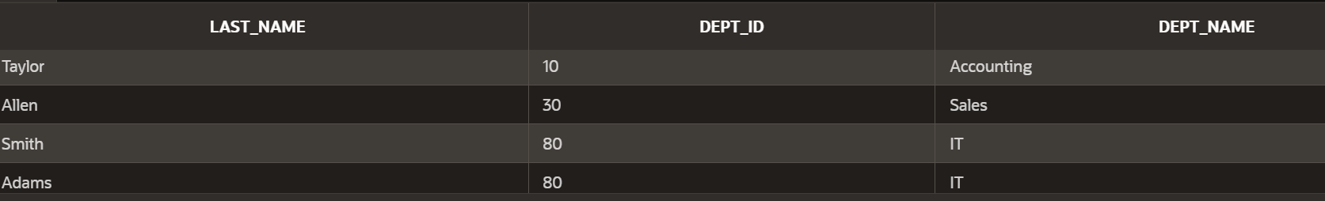

1. Create a unique listing of all jobs that are in department 80. Include the location of the department in the output.

select distinct dept_name,dept.location_id from dept,loction where dept.dept_id=80 and dept.location_id=loction.location_id;

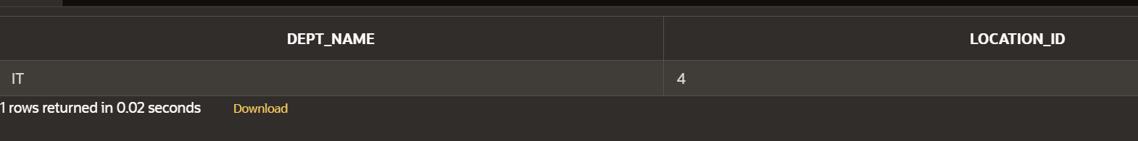

1. Write a query to display the employee last name, department name, location ID, and city of all employees who earn a commission

select e.last_name,d.dept_name,d.location_id,l.city from employee e join dept d on e.department_id=d.dept_id join loction l on d.location_id=l.location_id where e.commission_pct is not null;

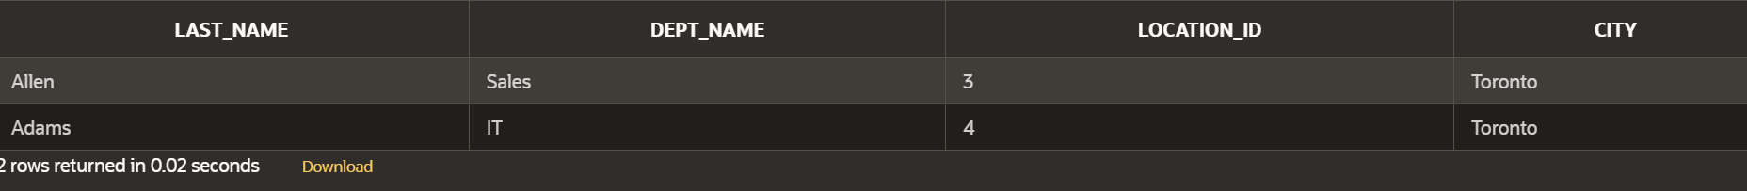

8. Display the employee last name and department name for all employees who have an

a(lowercase) in their last names. P

select last_name,dept_name from employee e,dept d where last_name like '%a%'and e.department_id=d.dept_id;

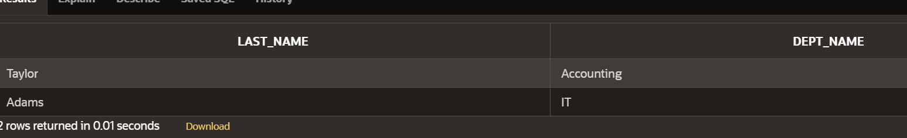

1. Write a query to display the last name, job, department number, and department name for all employees who work in Toronto.

select last_name,job_id,dept_id,dept_name from employee e join dept d on e.department_id=d.dept_id join loction l on d.location_id=l.location_id where city='Toronto';

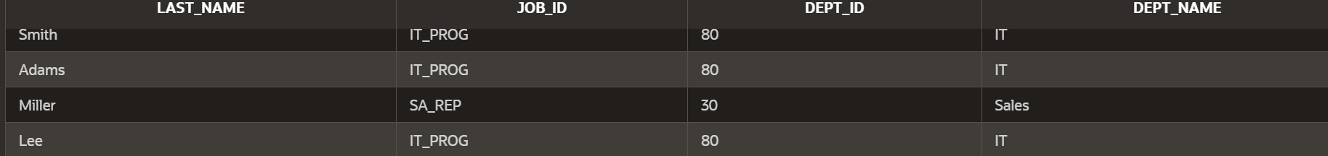

1. Display the employee last name and employee number along with their manager’s last name and manager number. Label the columns Employee, Emp#, Manager, and Mgr#, Respectively

select last_name,employee_id as emp#,dept.manager_id as mdr# from employee,dept;

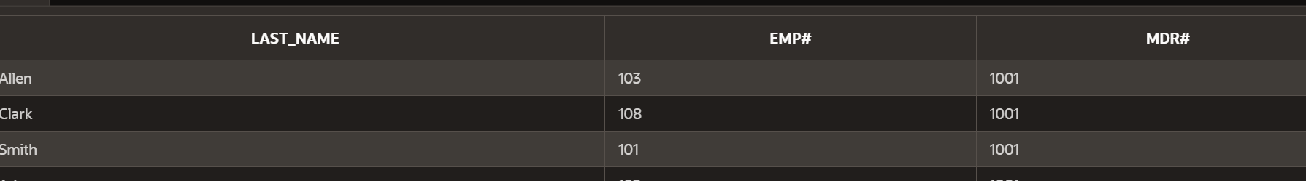

1. Modify lab4_6.sql to display all employees including King, who has no manager. Order the results by the employee number.

SELECT LAST_NAME,DEPT_NAME FROM employee E ,DEPT D WHERE E.MANAGER_ID IS NULL AND E.DEPARTMENT_ID=D.DEPT_ID ORDER BY EMPLOYEE_ID;



1. Create a query that displays employee last names, department numbers, and all the employees who work in the same department as a given employee. Give each column an appropriate label

SELECT e.LAST_NAME, d.DEPT_NAME FROM employee e

JOIN dept d ON e.DEPARTMENT_ID = d.DEPT_ID

WHERE e.DEPARTMENT_ID = (

SELECT DEPARTMENT_ID

FROM employee

WHERE FIRST_NAME = 'Jane' AND LAST_NAME = 'Adams'

);

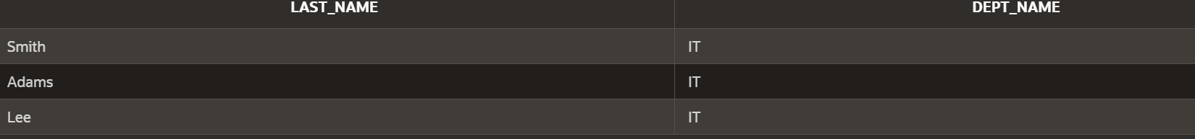

1. Show the structure of the JOB_GRADES table. Create a query that displays the name, job, department name, salary, and grade for all employees

SELECT LAST_NAME,JOB_ID,DEPT_NAME,SALARY,GRADE_LEVEL FROM employee E JOIN Dept D ON E.DEPARTMENT_ID=D.DEPT_ID

JOIN JOB_GRADE J ON E.SALARY BETWEEN J.LOWEST_SAL AND J.HIGHEST_SAL;

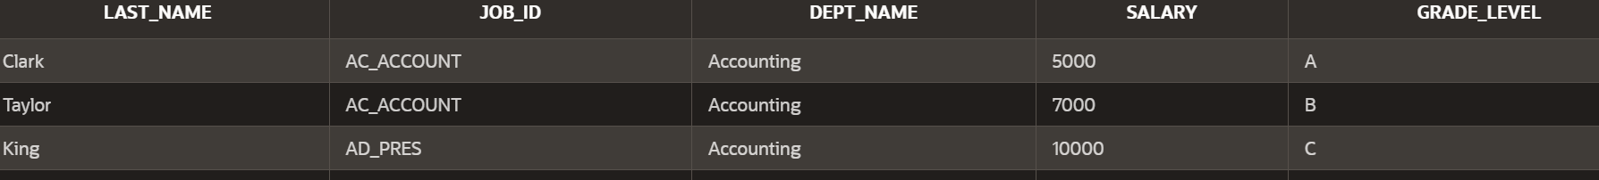

1. Create a query to display the name and hire date of any employee hired after employee Davies.

SELECT LAST_NAME AS EMPLOYEE_NAME,HIRE_DATE

FROM employee

WHERE HIRE_DATE > (

SELECT HIRE_DATE

FROM employee

WHERE LAST_NAME = 'Davies'

);

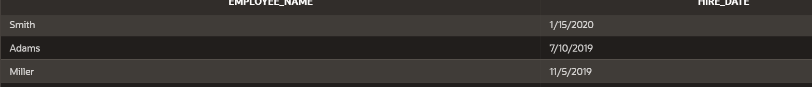

1. Display the names and hire dates for all employees who were hired before their managers, along with their manager’s names and hire dates. Label the columns Employee, Emp Hired, Manager, and Mgr Hired, respectively.

SELECT e.LAST_NAME AS "Employee",e.HIRE_DATE AS "Emp Hired",m.LAST_NAME AS "Manager",m.HIRE_DATE AS "Mgr Hired"

FROM employee e

JOIN employee m ON e.MANAGER_ID = m.EMPLOYEE_ID

WHERE e.HIRE_DATE < m.HIRE_DATE;

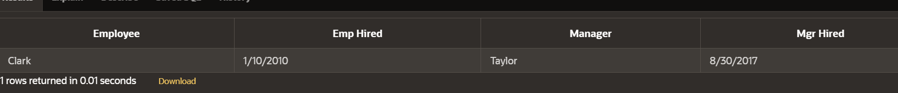

| Evaluation Procedure | Marks awarded |
| --- | --- |
| Query(5) |  |
| Execution (5) |  |
| Viva(5) |  |
| Total (15) |  |
| Faculty Signature |  |

###### EXERCISE-8

**Aggregating Data Using Group Functions**

***Objectives***

After the completion of this exercise, the students be will be able to do the following:

* Identify the available group functions
* Describe the use of group functions
* Group data by using the GROUP BY clause
* Include or exclude grouped rows by using the HAVING clause

**What Are Group Functions?**

Group functions operate on sets of rows to give one result per group

**Types of Group Functions**

* AVG
* COUNT
* MAX
* MIN
* STDDEV
* SUM
* VARIANCE

Each of the functions accepts an argument. The following table identifies the options that you can use in the syntax:

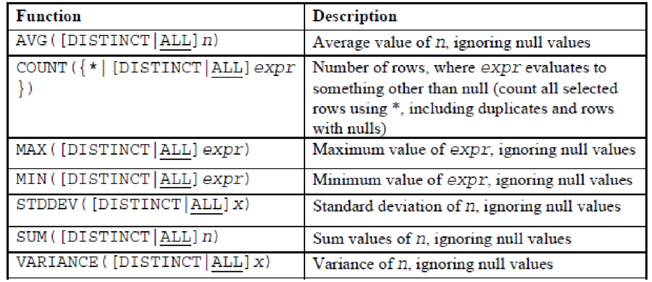

**Group Functions: Syntax**

SELECT [*column*,] *group_function(column), ...*

FROM *table*

[WHERE *condition*]

[GROUP BY *column*]

[ORDER BY *column*];

**Guidelines for Using Group Functions**

* DISTINCT makes the function consider only nonduplicate values; ALL makes it consider every value, including duplicates. The default is ALL and therefore does not need to be specified.

* The data types for the functions with an expr argument may be CHAR, VARCHAR2, NUMBER, or DATE.

* All group functions ignore null values.

**Using the AVG and SUM Functions**

You can use AVG and SUM for numeric data.

SELECT AVG(salary), MAX(salary),

MIN(salary), SUM(salary)

FROM employees

WHERE job_id LIKE '%REP%';

**Using the MIN and MAX Functions**

You can use MIN and MAX for numeric, character, and date data types.

SELECT MIN(hire_date), MAX(hire_date)

FROM employees;

You can use the MAX and MIN functions for numeric, character, and date data types. example displays the most junior and most senior employees.

The following example displays the employee last name that is first and the employee last name that is last in an alphabetized list of all employees:

SELECT MIN(last_name), MAX(last_name)

FROM employees;

**Note:** The AVG, SUM, VARIANCE, and STDDEV functions can be used only with numeric data types. MAX and MIN cannot be used with LOB or LONG data types.

**Using the COUNT Function**

COUNT(*) returns the number of rows in a table:

SELECT COUNT(*)

FROM employees

WHERE department_id = 50;

COUNT(*expr*) returns the number of rows with nonnull values for the *expr*:

SELECT COUNT(commission_pct)

FROM employees

WHERE department_id = 80;

**Using the DISTINCT Keyword**

* COUNT(DISTINCT expr) returns the number of distinct non-null values of the *expr*.

* To display the number of distinct department values in the EMPLOYEES table:

SELECT COUNT(DISTINCT department_id) FROM employees;

Use the DISTINCT keyword to suppress the counting of any duplicate values in a column.

**Group Functions and Null Values**

Group functions ignore null values in the column:

SELECT AVG(commission_pct)

FROM employees;

The NVL function forces group functions to include null values:

SELECT AVG(NVL(commission_pct, 0))

FROM employees;

**Creating Groups of Data**

To divide the table of information into smaller groups. This can be done by using the GROUP BY clause.

**GROUP BY Clause Syntax**

SELECT *column*, *group_function(column)*

FROM *table*

[WHERE *condition*]

[GROUP BY *group_by_expression*]

[ORDER BY *column*];

**In the syntax:** *group_by_expression* specifies columns whose values determine the basis for grouping rows

**Guidelines**

* If you include a group function in a SELECT clause, you cannot select individual results as well, *unless* the individual column appears in the GROUP BY clause. You receive an error message if you fail to include the column list in the GROUP BY clause.

* Using a WHERE clause, you can exclude rows before dividing them into groups.

* You must include the *columns* in the GROUP BY clause.

* You cannot use a column alias in the GROUP BY clause.

**Using the GROUP BY Clause**

All columns in the SELECT list that are not in group functions must be in the GROUP BY clause.

SELECT department_id, AVG(salary)

FROM employees

GROUP BY department_id ;

The GROUP BY column does not have to be in the SELECT list.

SELECT AVG(salary) FROM employees GROUP BY department_id ;

You can use the group function in the ORDER BY clause:

SELECT department_id, AVG(salary) FROM employees GROUP BY department_id ORDER BY AVG(salary);

**Grouping by More Than One Column**

SELECT department_id dept_id, job_id, SUM(salary) FROM employees

GROUP BY department_id, job_id ;

**Illegal Queries Using Group Functions**

Any column or expression in the SELECT list that is not an aggregate function must be in the

GROUP

**BY clause:**

SELECT department_id, COUNT(last_name) FROM employees;

You can correct the error by adding the GROUP BY clause:

SELECT department_id, count(last_name) FROM employees GROUP BY department_id;

You cannot use the WHERE clause to restrict groups.

* You use the HAVING clause to restrict groups.

* You cannot use group functions in the WHERE clause.

SELECT department_id, AVG(salary) FROM employees WHERE AVG(salary) > 8000 GROUP BY department_id;

You can correct the error in the example by using the HAVING clause to restrict groups:

SELECT department_id, AVG(salary) FROM employees

HAVING AVG(salary) > 8000 GROUP BY department_id;

**Restricting Group Results**

With the HAVING Clause .When you use the HAVING clause, the Oracle server restricts groups as follows:

1. Rows are grouped.
2. The group function is applied.
3. Groups matching the HAVING clause are displayed.

**Using the HAVING Clause**

SELECT department_id, MAX(salary) FROM employees

GROUP BY department_idHAVING MAX(salary)>10000 ;

The following example displays the department numbers and average salaries for those departments with a maximum salary that is greater than $10,000:

SELECT department_id, AVG(salary) FROM employees GROUP BY department_id HAVING max(salary)>10000;

Example displays the job ID and total monthly salary for each job that has a total payroll exceeding $13,000. The example excludes sales representatives and sorts the list by the total monthly salary.

SELECT job_id, SUM(salary) PAYROLL FROM employees WHERE job_id NOT LIKE '%REP%'

GROUP BY job_id HAVING SUM(salary) > 13000 ORDER BY SUM(salary);

**Nesting Group Functions**

**Display the maximum average salary:**

Group functions can be nested to a depth of two. The slide example displays the maximum average salary.

SELECT MAX(AVG(salary)) FROM employees GROUP BY department_id; **Summary**

In this exercise, students should have learned how to:

* Use the group functions COUNT, MAX, MIN, and AVG
* Write queries that use the GROUP BY clause
* Write queries that use the HAVING clause

SELECT *column*, *group_function*

FROM *table*

[WHERE *condition*]

[GROUP BY *group_by_expression*]

[HAVING *group_condition*] [ORDER BY *column*];

**Find the Solution for the following:**

Determine the validity of the following three statements. Circle either True or False.

1. Group functions work across many rows to produce one result per group. True/False

1. Group functions include nulls in calculations.

True/False

1. The WHERE clause restricts rows prior to inclusion in a group calculation. True/False

**The HR department needs the following reports:**

1. Find the highest, lowest, sum, and average salary of all employees. Label the columns Maximum, Minimum, Sum, and Average, respectively. Round your results to the nearest whole number

select round(max(salary) )as MAXIMUM,round(min(salary)) as MINIMUN,round(sum(salary)) as SUM,round(avg(salary)) as AVERAGE from employee;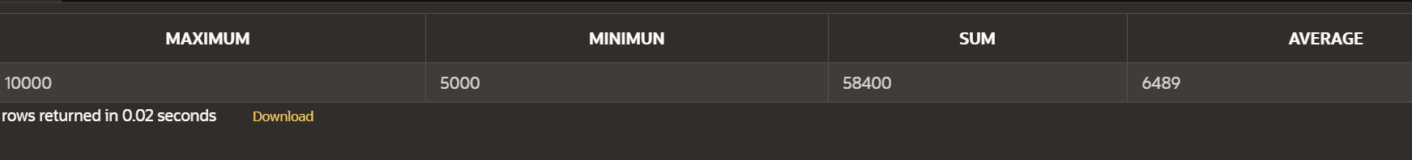

1. Modify the above query to display the minimum, maximum, sum, and average salary for each job type.

select job_id, round(max(salary) )as MAXIMUM,round(min(salary)) as MINIMUN,round(sum(salary)) as SUM,round(avg(salary)) as AVERAGE from employee group by job_id;

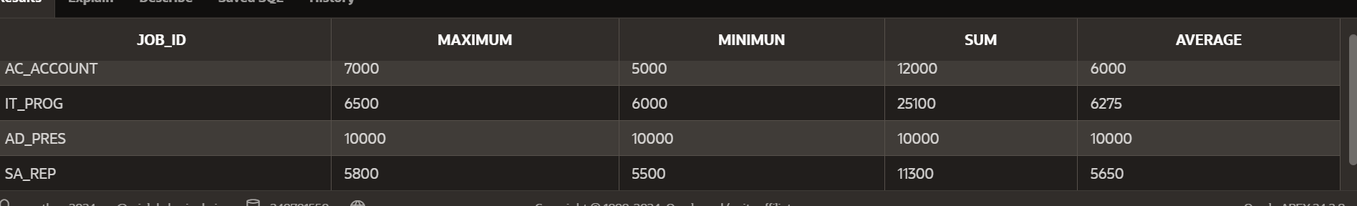

6.Write a query to display the number of people with the same job. Generalize the query so that the user in the HR department is prompted for a job title.

select job_id,count(*) as Number_of_people from employee where job_id=:job_title group by job_id;

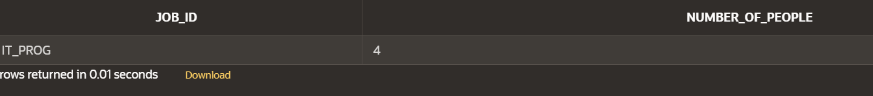

1. Determine the number of managers without listing them. Label the column Number of Managers. *Hint: Use the MANAGER_ID column to determine the number of* *managers.*

select count(manager_id ) as number_of_manager from employee where manager_id is not null;

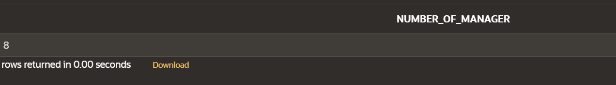

1. Find the difference between the highest and lowest salaries. Label the column

DIFFERENCE.

select max(salary)-min(salary) as DIFFERENCE from employee;

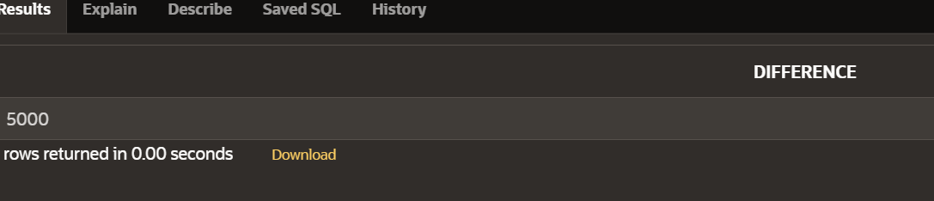

1. Create a report to display the manager number and the salary of the lowest-paid employee for that manager. Exclude anyone whose manager is not known. Exclude any groups where the minimum salary is $6,000 or less. Sort the output in descending order of salary.

select manager_id,min(salary) from employee where manager_id is not null group by manager_id having min(salary)>6000 order by min(salary) desc;

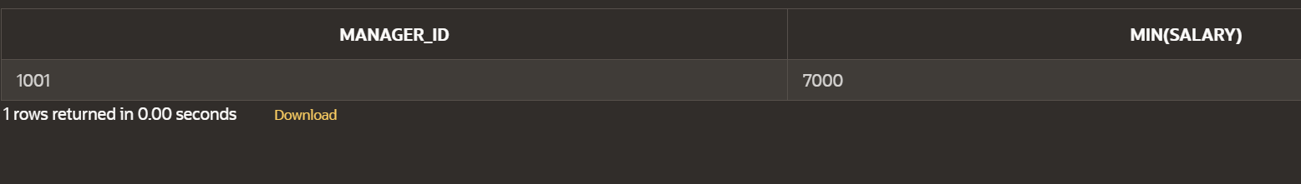

1. Create a query to display the total number of employees and, of that total, the number of employees hired in 1995, 1996, 1997, and 1998. Create appropriate column headings.

SELECT

COUNT(*) AS "Total Employees",

SUM(CASE WHEN TO_CHAR(hire_date, 'YYYY') = '1995' THEN 1 ELSE 0 END) AS "Hired in 1995",

SUM(CASE WHEN TO_CHAR(hire_date, 'YYYY') = '1996' THEN 1 ELSE 0 END) AS "Hired in 1996",

SUM(CASE WHEN TO_CHAR(hire_date, 'YYYY') = '1997' THEN 1 ELSE 0 END) AS "Hired in 1997",

SUM(CASE WHEN TO_CHAR(hire_date, 'YYYY') = '1998' THEN 1 ELSE 0 END) AS "Hired in 1998"

FROM employees;

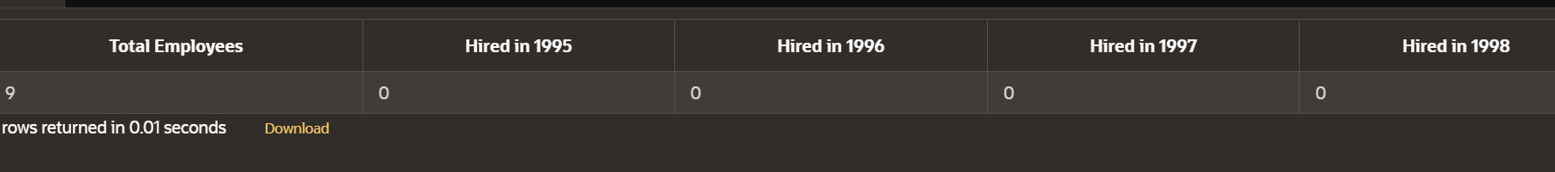

1. Create a matrix query to display the job, the salary for that job based on department number, and the total salary for that job, for departments 20, 50, 80, and 90, giving each column an appropriate heading.

select job_id,department_id,sum(salary) from employee where department_id in (20,50,80,90) group by job_id,department_id order by department_id,job_id;

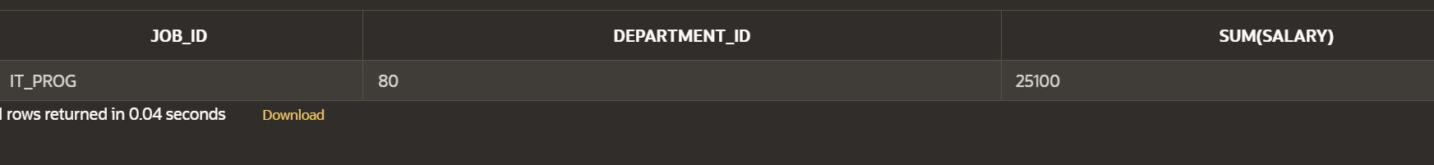

12.Write a query to display each department’s name, location, number of employees, and the average salary for all the employees in that department. Label the column name-Location, Number of people, and salary respectively. Round the average salary to two decimal places. select d.dept_name as names,d.location_id as locations ,count(employee_id) as no_of_people,round(avg(e.salary),2)as salary from department d join employee e on d.dept_id=e.department_id group by d.dept_name,d.location_id order by d.dept_name;

| Evaluation Procedure | Marks awarded |
| --- | --- |
| Query(5) |  |
| Execution (5) |  |
| Viva(5) |  |
| Total (15) |  |
| Faculty Signature |  |

###### EXERCISE-9

###### Sub queries

**Objectives**

After completing this lesson, you should be able to do the following:

* Define subqueries
* Describe the types of problems that subqueries can solve
* List the types of subqueries
* Write single-row and multiple-row subqueries

**Using a Subquery to Solve a Problem** Who has a salary greater than Abel’s?

**Main query:**

Which employees have salaries greater than Abel’s salary?

**Subquery:**

What is Abel’s salary?

**Subquery Syntax**

SELECT *select_list* FROM *table* WHERE *expr operator* (SELECT *select_list* FROM *table*);

* The subquery (inner query) executes once before the main query (outer query).

* The result of the subquery is used by the main query.

A subquery is a SELECT statement that is embedded in a clause of another SELECT statement. You can build powerful statements out of simple ones by using subqueries. They can be very useful when you need to select rows from a table with a condition that depends on the data in the table itself.

You can place the subquery in a number of SQL clauses, including the following:

* WHERE clause
* HAVING clause
* FROM clause

**In the syntax:**

*operator* includes a comparison condition such as >, =, or IN

**Note:** Comparison conditions fall into two classes: single-row operators

(>, =, >=, <, <>, <=) and multiple-row operators (IN, ANY, ALL). statement. The subquery generally executes first, and its output is used to complete the query condition for the main (or outer) query

**Using a Subquery**

SELECT last_name FROM employees WHERE salary > (SELECT salary FROM employees WHERE last_name = 'Abel');

The inner query determines the salary of employee Abel. The outer query takes the result of the inner query and uses this result to display all the employees who earn more than this amount.

**Guidelines for Using Subqueries**

* Enclose subqueries in parentheses.

* Place subqueries on the right side of the comparison condition.

* The ORDER BY clause in the subquery is not needed unless you are performing Top-N analysis.

* Use single-row operators with single-row

subqueries, and use multiple-row operators with multiple-row subqueries.

**Types of Subqueries**

* Single-row subqueries: Queries that return only one row from the inner SELECT statement.

* Multiple-row subqueries: Queries that return more than one row from the inner SELECT statement.

**Single-Row Subqueries**

* Return only one row

* Use single-row comparison operators

**Example**

Display the employees whose job ID is the same as that of employee 141:

SELECT last_name, job_id FROM employees WHERE job_id = (SELECT job_id FROM employees

WHERE employee_id = 141);

Displays employees whose job ID is the same as that of employee 141 and whose salary is greater than that of employee 143.

SELECT last_name, job_id, salary FROM employeesWHERE job_id =(SELECT job_id FROM employees WHERE employee_id = 141) AND salary > (SELECT salary FROM employees WHERE employee_id = 143);

**Using Group Functions in a Subquery**

Displays the employee last name, job ID, and salary of all employees whose salary is equal to the minimum salary. The MIN group function returns a single value (2500) to the outer query.

SELECT last_name, job_id, salary FROM employees WHERE salary = (SELECT MIN(salary)

FROM employees);

**The HAVING Clause with Subqueries**

* The Oracle server executes subqueries first.

* The Oracle server returns results into the HAVING clause of the main query.

Displays all the departments that have a minimum salary greater than that of department 50.

SELECT department_id, MIN(salary)

FROM employees

GROUP BY department_id

HAVING MIN(salary) >

(SELECT MIN(salary)

FROM employees

WHERE department_id = 50);

**Example**

**Find the job with the lowest average salary.**

SELECT job_id, AVG(salary)

FROM employees

GROUP BY job_id

HAVING AVG(salary) = (SELECT MIN(AVG(salary))

FROM employees

GROUP BY job_id);

**What Is Wrong in this Statements?**

SELECT employee_id, last_name

FROM employees

WHERE salary =(SELECT MIN(salary) FROM employees GROUP BY department_id); Will This Statement Return Rows?

SELECT last_name, job_id

FROM employees

WHERE job_id =(SELECT job_id FROM employees WHERE last_name = 'Haas');

**Multiple-Row Subqueries**

* Return more than one row

* Use multiple-row comparison operators

**Example**

Find the employees who earn the same salary as the minimum salary for each department.

SELECT last_name, salary, department_id FROM employees WHERE salary IN (SELECT MIN(salary)

FROM employees GROUP BY department_id);

Using the ANY Operator in Multiple-Row Subqueries

SELECT employee_id, last_name, job_id, salary FROM employees WHERE salary < ANY

(SELECT salary FROM employees WHERE job_id = 'IT_PROG') AND job_id <> 'IT_PROG'; Displays employees who are not IT programmers and whose salary is less than that of any IT programmer. The maximum salary that a programmer earns is $9,000.

< ANY means less than the maximum. >ANY means more than the minimum. =ANY is equivalent to IN.

**Using the ALL Operator in Multiple-Row Subqueries**

SELECT employee_id, last_name, job_id, salary

FROM employees

WHERE salary < ALL (SELECT salary FROM employees WHERE job_id = 'IT_PROG') AND job_id <> 'IT_PROG';

Displays employees whose salary is less than the salary of all employees with a job ID of IT_PROG and whose job is not IT_PROG.

⮚ ALL means more than the maximum, and <ALL means less than the minimum.

The NOT operator can be used with IN, ANY, and ALL operators.

**Null Values in a Subquery**

SELECT emp.last_name FROM employees emp

WHERE emp.employee_id NOT IN (SELECT mgr.manager_id FROM employees mgr);

Notice that the null value as part of the results set of a subquery is not a problem if you use the IN operator. The IN operator is equivalent to =ANY. For example, to display the employees who have subordinates, use the following SQL statement:

SELECT emp.last_name

FROM employees emp

WHERE emp.employee_id IN (SELECT mgr.manager_id FROM employees mgr);

Display all employees who do not have any subordinates:

SELECT last_name FROM employees

WHERE employee_id NOT IN (SELECT manager_id FROM employees WHERE manager_id IS NOT NULL);

**Find the Solution for the following:**

1. The HR department needs a query that prompts the user for an employee last name. The query then displays the last name and hire date of any employee in the same department as the employee whose name they supply (excluding that employee). For example, if the user enters Zlotkey, find all employees who work with Zlotkey (excluding Zlotkey).

select last_name,hire_date from employee where department_id = (select department_id from employee where last_name=:last_name) and last_name not in ('adams');

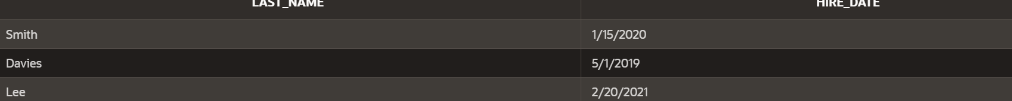

1. Create a report that displays the employee number, last name, and salary of all employees who earn more than the average salary. Sort the results in order of ascending salary.

select employee_id,last_name,salary from employee where salary >(select avg(salary) from employee) order by salary asc;

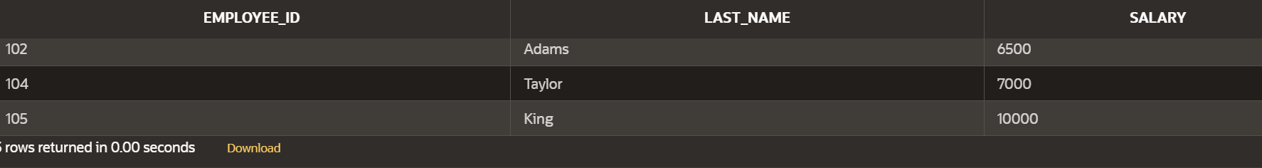

1. Write a query that displays the employee number and last name of all employees who work in a department with any employee whose last name contains a *u*.

select employee_id,last_name from employee where department_id in (select last_name from employee where last_name like '%u%');

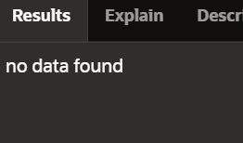

1. The HR department needs a report that displays the last name, department number, and job ID of all employees whose department location ID is 1700.

select last_name,department_id,job_id from employee ,department where LOCATION_ID =1700 ;

1. Create a report for HR that displays the last name and salary of every employee who reports to King.

elect last_name,salary from employee where manager_id=(select employee_id from employee where last_name='king');



1. Create a report for HR that displays the department number, last name, and job ID for every employee in the Executive department.

select department_id,last_name,job_id from employee e join department d on e.department_id=d.dept_id where dept_name='IT';

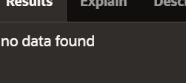

1. Modify the query 3 to display the employee number, last name, and salary of all employees who earn more than the average salary and who work in a department with any employee whose last name contains a *u*.

select employee_id,last_name,salary from employee where salary>(select avg(salary) from employee ) and department_id in (select distinct department_id from employee where last_name like '%u%');

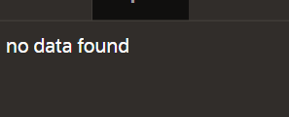

| Evaluation Procedure | Marks awarded |
| --- | --- |
| Query(5) |  |
| Execution (5) |  |
| Viva(5) |  |
| Total (15) |  |
| Faculty Signature |  |

###### EXERCISE-10

###### USING THE SET OPERATORS

**Objectives**

After the completion this exercise, the students should be able to do the following:

* Describe set operators
* Use a set operator to combine multiple queries into a single query
* Control the order of rows returned

The set operators combine the results of two or more component queries into one result.

Queries containing set operators are called *compound queries*.

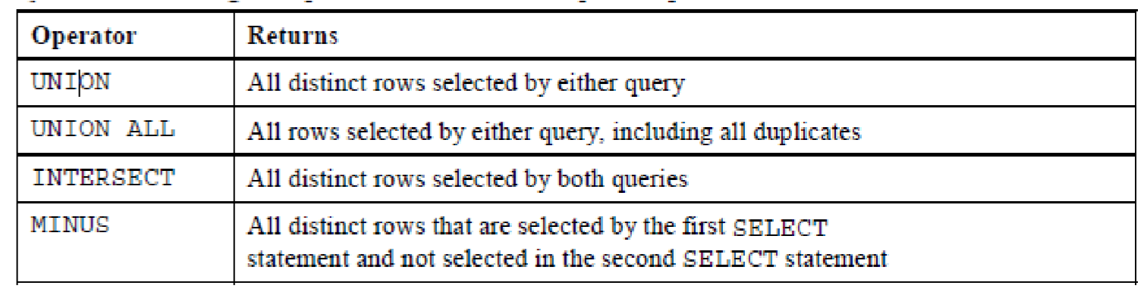

**The tables used in this lesson are:**

* EMPLOYEES: Provides details regarding all current employees

* JOB_HISTORY: Records the details of the start date and end date of the former job, and the job identification number and department when an employee switches jobs

**UNION Operator**

**Guidelines**

* The number of columns and the data types of the columns being selected must be identical in all the SELECT statements used in the query. The names of the columns need not be identical.

* UNION operates over all of the columns being selected.

* NULL values are not ignored during duplicate checking.

* The IN operator has a higher precedence than the UNION operator.

* By default, the output is sorted in ascending order of the first column of the SELECT clause.

**Example:**

Display the current and previous job details of all employees. Display each employee only once.

SELECT employee_id, job_id FROM employees UNION SELECT employee_id, job_id FROM job_history;

**Example:**

SELECT employee_id, job_id, department_id

FROM employees

UNION

SELECT employee_id, job_id, department_id

FROM job_history;

**UNION ALL Operator**

**Guidelines**

The guidelines for UNION and UNION ALL are the same, with the following two exceptions that pertain to UNION ALL:

* Unlike UNION, duplicate rows are not eliminated and the output is not sorted by default.
* The DISTINCT keyword cannot be used. **Example:**

Display the current and previous departments of all employees.

SELECT employee_id, job_id, department_id

FROM employees

UNION ALL

SELECT employee_id, job_id, department_id

FROM job_history

ORDER BY employee_id;

**INTERSECT Operator**

**Guidelines**

* The number of columns and the data types of the columns being selected by the SELECT statements in the queries must be identical in all the SELECT statements used in the query. The names of the columns need not be identical.
* Reversing the order of the intersected tables does not alter the result.
* INTERSECT does not ignore NULL values.

**Example:**

Display the employee IDs and job IDs of those employees who currently have a job title that is the same as their job title when they were initially hired (that is, they changed jobs but have now gone back to doing their original job).

SELECT employee_id, job_id FROM employees

INTERSECT

SELECT employee_id, job_id

FROM job_history;

**Example**

SELECT employee_id, job_id, department_id

FROM employees

INTERSECT

SELECT employee_id, job_id, department_id

FROM job_history;

**MINUS Operator**

**Guidelines**

* The number of columns and the data types of the columns being selected by the SELECT statements in the queries must be identical in all the SELECT statements used in the query. The names of the columns need not be identical.
* All of the columns in the WHERE clause must be in the SELECT clause for the MINUS operator to work.

**Example:**

Display the employee IDs of those employees who have not changed their jobs even once.

SELECT employee_id,job_id

FROM employees

MINUS

SELECT employee_id,job_id

FROM job_history;

**Find the Solution for the following:**

1. The HR department needs a list of department IDs for departments that do not contain the job ID ST_CLERK. Use set operators to create this report.

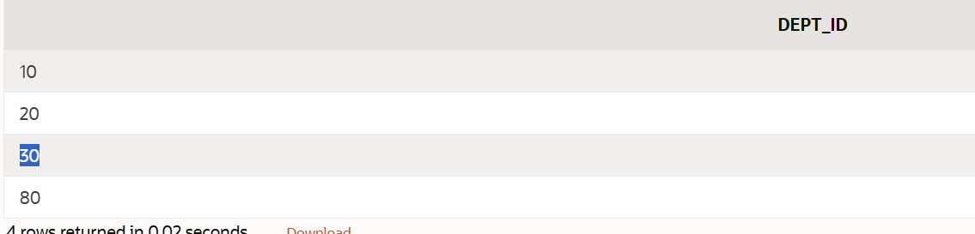

1. The HR department needs a list of countries that have no departments located in them.

Display the country ID and the name of the countries. Use set operators to create this report.

1. Produce a list of jobs for departments 10, 50, and 20, in that order. Display job ID and department ID using set operators.

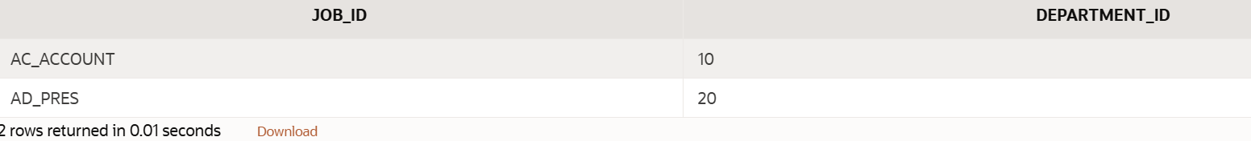

1. Create a report that lists the employee IDs and job IDs of those employees who currently have a job title that is the same as their job title when they were initially hired by the company (that is, they changed jobs but have now gone back to doing their original job).

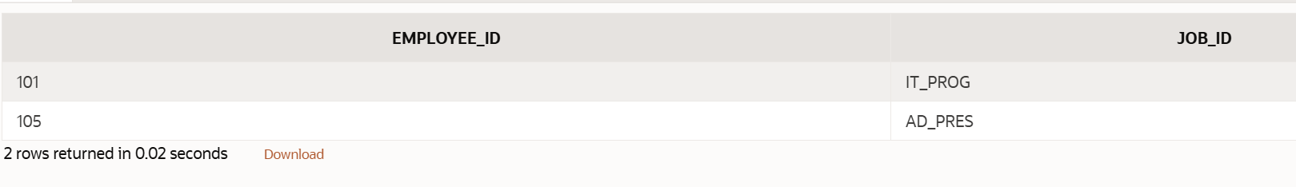

1. The HR department needs a report with the following specifications:

* Last name and department ID of all the employees from the EMPLOYEES table, regardless of whether or not they belong to a department.

* Department ID and department name of all the departments from the DEPARTMENTS table, regardless of whether or not they have employees working in them Write a compound query to accomplish this.

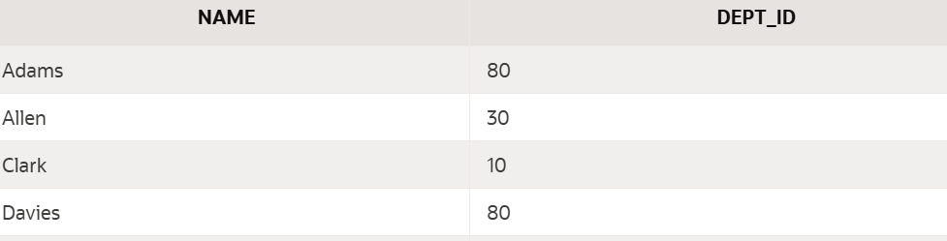

| Evaluation Procedure | Marks awarded |
| --- | --- |
| Query(5) |  |
| Execution (5) |  |
| Viva(5) |  |
| Total (15) |  |
| Faculty Signature |  |

###### EXERCISE-11

###### CREATING VIEWS

After the completion of this exercise, students will be able to do the following:

* Describe a view
* Create, alter the definition of, and drop a view
* Retrieve data through a view
* Insert, update, and delete data through a view
* Create and use an inline view

**View**

A view is a logical table based on a table or another view. A view contains no data but is like a window through which data from tables can be viewed or changed.The tables on which a view is based are called base tables.

**Advantages of Views**

* To restrict data access
* To make complex queries easy
* To provide data independence
* To present different views of the same data

**Classification of views**

1. Simple view
2. Complex view

| Feature | Simple | Complex |
| --- | --- | --- |
| No. of tables | One | One or more |
| Contains functions | No | Yes |
| Contains groups of data | No | Yes |
| DML operations thr’ view | Yes | Not always |

**Creating a view**

**Syntax**

CREATE OR REPLACE FORCE/NOFORCE VIEW view_name AS Subquery WITH CHECK OPTION CONSTRAINT constraint WITH READ ONLY CONSTRAINT constraint;

**FORCE** - Creates the view regardless of whether or not the base tables exist.

**NOFORCE** - Creates the view only if the ase table exist.

WITH CHECK OPTION CONSTRAINT-specifies that only rows accessible to the view can be inserted or updated.

WITH READ ONLY CONSTRAINT-ensures that no DML operations can be performed on the view.

**Example: 1** (W**ithout using Column aliases)**

Create a view EMPVU80 that contains details of employees in department80.

**Example 2:**

CREATE VIEW empvu80 AS SELECT employee_id, last_name, salary FROM employees

WHERE department_id=80;

**Example:1** (**Using column aliases)**

CREATE VIEW salvu50

AS SELECT employee_id,id_number, last_name NAME, salary *12 ANN_SALARY

FROM employees

WHERE department_id=50;

**Retrieving data from a view**

**Example:**

SELECT * from salvu50;

**Modifying a view**

A view can be altered without dropping, re-creating.

**Example:** **(Simple view)**

Modify the EMPVU80 view by using CREATE OR REPLACE.

CREATE OR REPLACE VIEW empvu80 (id_number, name, sal, department_id)

AS SELECT employee_id,first_name, last_name, salary, department_id

FROM employees

WHERE department_id=80;

**Example**: **(complex view)**

CREATE VIEW dept_sum_vu (name, minsal, maxsal,avgsal)

AS SELECT d.department_name, MIN(e.salary), MAX(e.salary), AVG(e.salary)

FROM employees e, department d

WHERE e.deparment_id=d.deparment_id

GROUP BY d.department_name;

**Rules for performing DML operations on view**

* Can perform operations on simple views
* Cannot remove a row if the view contains the following:

▪ Group functions

▪ Group By clause

▪ Distinct keyword

* Cannot modify data in a view if it contains

▪ Group functions

▪ Group By clause

▪ Distinct keyword

▪ Columns contain by expressions

▪

* Cannot add data thr’ a view if it contains

▪ Group functions

▪ Group By clause

▪ Distinct keyword

▪ Columns contain by expressions

▪ NOT NULL columns in the base table that are not selected by the view

**Example: (Using the WITH CHECK OPTION clause)**

CREATE OR REPLACE VIEW empvu20

AS SELECT *

FROM employees

WHERE department_id=20

WITH CHECK OPTION CONSTRAINT empvu20_ck;

**Note:**Any attempt to change the department number for any row in the view fails because it violates the WITH CHECK OPTION constraint.

**Example** – (Execute this and note the error)

UPDATE empvu20 SET department_id=10 WHERE employee_id=201;

**Denying DML operations**

Use of WITH READ ONLY option.

Any attempt to perform a DML on any row in the view results in an oracle server error.

**Try this code:**

CREATE OR REPLACE VIEW empvu10(employee_number, employee_name,job_title)

AS SELECT employee_id, last_name, job_id

FROM employees

WHERE department_id=10

WITH READ ONLY;

**Find the Solution for the following:**

1. Create a view called EMPLOYEE_VU based on the employee numbers, employee names and department numbers from the EMPLOYEES table. Change the heading for the employee name to EMPLOYEE.

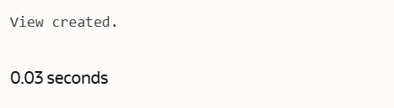

1. Display the contents of the EMPLOYEES_VU view.

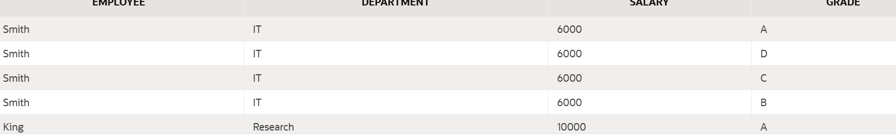

1. Select the view name and text from the USER_VIEWS data dictionary views.

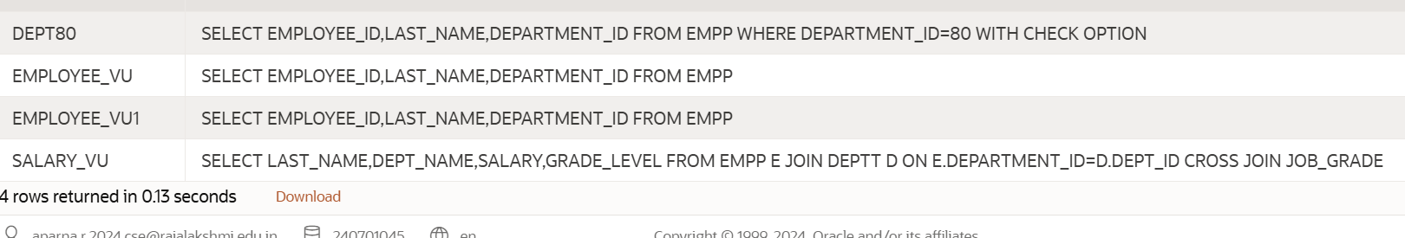

1. Using your EMPLOYEES_VU view, enter a query to display all employees names and department.

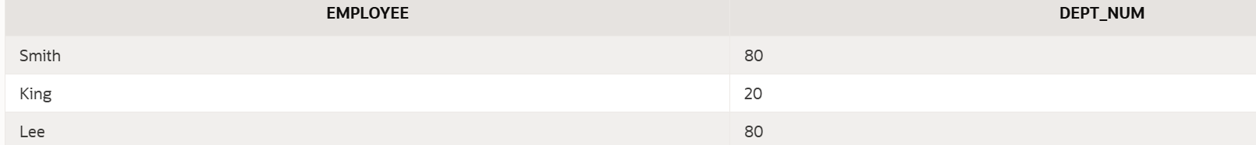

1. Create a view named DEPT50 that contains the employee number, employee last names and department numbers for all employees in department 50.Label the view columns EMPNO, EMPLOYEE and DEPTNO. Do not allow an employee to be reassigned to another department through the view.

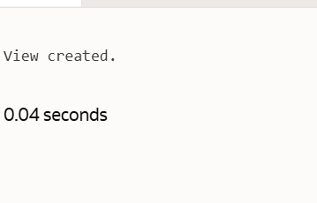

1. Display the structure and contents of the DEPT50 view.

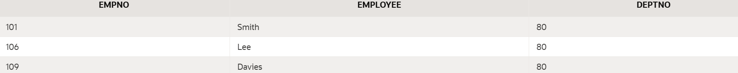

1. Attempt to reassign Matos to department 80.

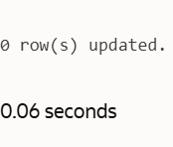

1. Create a view called SALARY_VU based on the employee last names, department names, salaries, and salary grades for all employees. Use the Employees, DEPARTMENTS and JOB_GRADE tables. Label the column Employee, Department, salary, and Grade respectively.

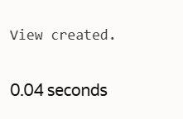

| Evaluation Procedure | Marks awarded |
| --- | --- |
| Query(5) |  |
| Execution (5) |  |
| Viva(5) |  |
| Total (15) |  |
| Faculty Signature |  |

**EXERCISE 12**

**Intro to Constraints; NOT NULL and UNIQUE Constraints**

Global Fast Foods has been very successful this past year and has opened several new stores. They need to add a table to their database to store information about each of their store’s locations. The owners want to make sure that all entries have an identification number, date opened, address, and city and that no other entry in the table can have the same email address. Based on this information, answer the following questions about the global_locations table. Use the table for your answers.

| **Global Fast Foods global_locations Table** | | | |  |  |  |
| --- | --- | --- | --- | --- | --- | --- |
| **NAME** | **TYPE** | **LENGTH** | **PRECISION** | **SCALE** | **NULLABLE** | **DEFAULT** |
| Id |  |  |  |  |  |  |
| name |  |  |  |  |  |  |
| date_opened |  |  |  |  |  |  |
| address |  |  |  |  |  |  |
| city |  |  |  |  |  |  |
| zip/postal code |  |  |  |  |  |  |
| phone |  |  |  |  |  |  |
| email |  |  |  |  |  |  |
| manager_id |  |  |  |  |  |  |
| Emergency contact |  |  |  |  |  |  |

1. What is a “constraint” as it relates to data integrity?

A database constraint is a rule applied to data within a table to ensure its accuracy, consistency, and reliability, upholding data integrity by preventing invalid entries or actions.

1. What are the limitations of constraints that may be applied at the column level and at the table level?

A database constraint is a rule applied to data within a table to ensure its accuracy, consistency, and reliability, upholding data integrity by preventing invalid entries or actions.

1. Why is it important to give meaningful names to constraints?

Meaningful names make constraints easier to identify, manage (e.g., enable/disable/drop), and understand their purpose, especially during troubleshooting or schema changes. They improve database maintainability and collaboration among developers.

1. Based on the information provided by the owners, choose a datatype for each column. Indicate the length, precision, and scale for each NUMBER datatype.

Id: INT PRIMARY KEY (ensures uniqueness and non-nullability for identification)

name: VARCHAR(255) NOT NULL (stores varying length strings for the store name, mandatory)

date opened: DATE NOT NULL (stores date values for when the store opened, mandatory)

address: VARCHAR(255) NOT NULL (stores varying length strings for the address, mandatory)

city: VARCHAR(100) NOT NULL (stores varying length strings for the city, mandatory)

zip/postal code: VARCHAR(10) NULLABLE (stores varying length strings for the code, optional)

phone: VARCHAR(20) NULLABLE (stores varying length strings for the phone, optional)

email: VARCHAR(255) UNIQUE NOT NULL (stores varying length strings for email, must be unique and mandatory)

manager id: INT NULLABLE (stores integer for manager ID, optional)

Emergency contact: VARCHAR(255) NULLABLE (stores varying length strings for emergency contact, optional)

1. Use “(nullable)” to indicate those columns that can have null values.

Id (NOT NULL as it's a PRIMARY KEY)

name (NOT NULL)

date opened (NOT NULL)

address (NOT NULL)

city (NOT NULL)

zip/postal code (nullable)

phone (nullable)

email (NOT NULL, UNIQUE)

manager id (nullable)

Emergency contact (nullable)

AI responses may include mistakes.

1. Write the CREATE TABLE statement for the Global Fast Foods locations table to define the constraints at the column level.

CREATE TABLE global_fast_foods_locations ( id NUMBER PRIMARY KEY, loc_name VARCHAR2(20) NOT NULL, address VARCHAR2(30) NOT NULL, city VARCHAR2(20) NOT NULL, zip_postal VARCHAR2(20) NOT NULL, phone VARCHAR2(15), email VARCHAR2(80), manager_id NUMBER, contact VARCHAR2(40) );

1. Execute the CREATE TABLE statement in Oracle Application Express.

Executed

1. Execute a DESCRIBE command to view the Table Summary information.

DESCRIBE global_fast_foods_locations;

1. Rewrite the CREATE TABLE statement for the Global Fast Foods locations table to define the UNIQUE constraints at the table level. Do not execute this statement.

CREATE TABLE global_fast_foods_locations ( id NUMBER, loc_name VARCHAR2(20) NOT NULL, address VARCHAR2(30) NOT NULL, city VARCHAR2(20) NOT NULL, zip_postal VARCHAR2(20) NOT NULL, phone VARCHAR2(15), email VARCHAR2(80), manager_id NUMBER, contact VARCHAR2(40), CONSTRAINT pk_global_locations PRIMARY KEY (id), CONSTRAINT uk_loc_name UNIQUE (loc_name), CONSTRAINT uk_email UNIQUE (email) );

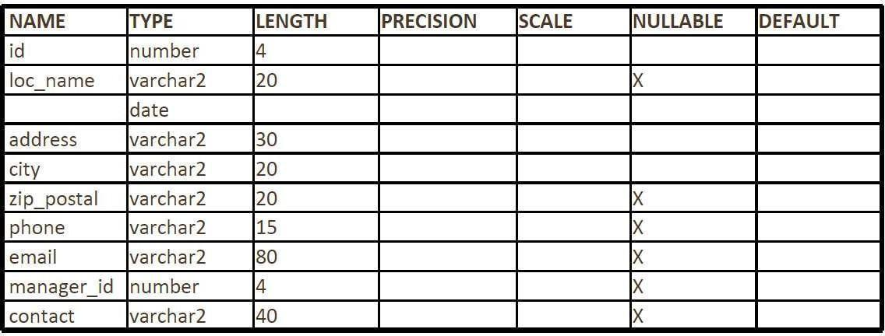

| Evaluation Procedure | Marks awarded |
| --- | --- |
| Query(5) |  |
| Execution (5) |  |
| Viva(5) |  |
| Total (15) |  |
| Faculty Signature |  |

**EXERCISE 13**

**Creating Views**

1. What are three uses for a view from a DBA’s perspective?

A view can restrict access to specific rows and columns

1. Create a simple view called view_d_songs that contains the ID, title and artist from the DJs on Demand table for each “New Age” type code. In the subquery, use the alias “Song Title” for the title column.

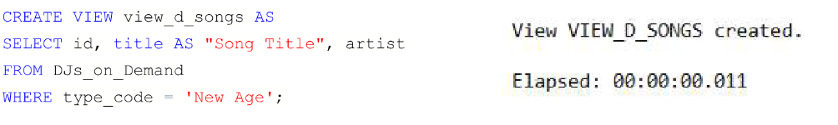

1. SELECT * FROM view_d_songs. What was returned?

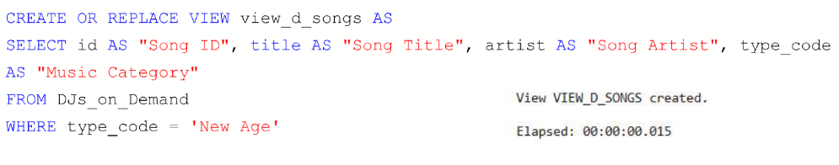

1. REPLACE view_d_songs. Add type_code to the column list. Use aliases for all columns.

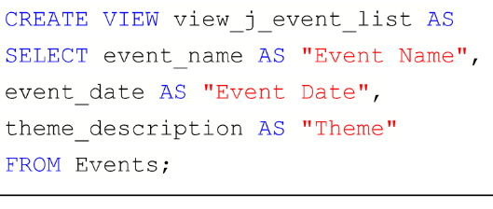

Or use alias after the CREATE statement as shown.

1. Jason Tsang, the disk jockey for DJs on Demand, needs a list of the past events and those planned for the coming months so he can make arrangements for each event’s equipment setup. As the company manager, you do not want him to have access to the price that clients paid for their events. Create a view for Jason to use that displays the name of the event, the event date, and the theme description. Use aliases for each column name.

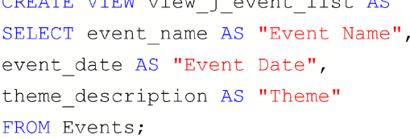

1. It is company policy that only upper-level management be allowed access to individual employee salaries. The department managers, however, need to know the minimum, maximum, and average salaries, grouped by department. Use the Oracle database to prepare a view that displays the needed information for department managers.

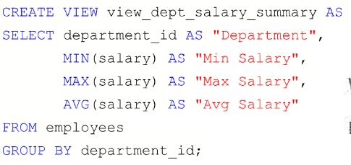

###### EXERCISE-14

###### OTHER DATABASE OBJECTS

**Objectives**

After the completion of this exercise, the students will be able to do the following:

* Create, maintain, and use sequences
* Create and maintain indexes

**Database Objects**

Many applications require the use of unique numbers as primary key values. You can either build code into the application to handle this requirement or use a sequence to generate unique numbers. If you want to improve the performance of some queries, you should consider creating an index. You can also use indexes to enforce uniqueness on a column or a collection of columns.

You can provide alternative names for objects by using synonyms.

**What Is a Sequence?** A sequence:

* Automatically generates unique numbers
* Is a sharable object
* Is typically used to create a primary key value
* Replaces application code
* Speeds up the efficiency of accessing sequence values when cached in memory

**The CREATE SEQUENCE Statement Syntax**

Define a sequence to generate sequential numbers automatically:

CREATE SEQUENCE *sequence*

[INCREMENT BY *n*]

[START WITH *n*]

[{MAXVALUE *n* | NOMAXVALUE}]

[{MINVALUE *n* | NOMINVALUE}]

[{CYCLE | NOCYCLE}] [{CACHE *n* | NOCACHE}];

**In the syntax:**

*sequence* is the name of the sequence generator

INCREMENT BY *n* specifies the interval between sequence numbers where *n* is an integer (If this clause is omitted, the sequence increments by 1.)

START WITH *n* specifies the first sequence number to be generated (If this clause is omitted, the sequence starts with 1.)

MAXVALUE *n* specifies the maximum value the sequence can generate

NOMAXVALUE specifies a maximum value of 10^27 for an ascending sequence and –1 for a descending sequence (This is the default option.)

MINVALUE *n* specifies the minimum sequence value

NOMINVALUE specifies a minimum value of 1 for an ascending sequence and – (10^26) for a descending sequence (This is the default option.)

CYCLE | NOCYCLE specifies whether the sequence continues to generate values after reaching its maximum or minimum value (NOCYCLE is the default option.)

CACHE *n* | NOCACHE specifies how many values the Oracle server preallocates and keep in memory (By default, the Oracle server caches 20 values.)

**Creating a Sequence**

* Create a sequence named DEPT_DEPTID_SEQ to be used for the primary key of the DEPARTMENTS table.
* Do not use the CYCLE option.

**EXAMPLE:**

CREATE SEQUENCE dept_deptid_seq

INCREMENT BY 10

START WITH 120

MAXVALUE 9999

NOCACHE

NOCYCLE;

**Confirming Sequences**

* Verify your sequence values in the USER_SEQUENCES data dictionary table.

* The LAST_NUMBER column displays the next available sequence number if NOCACHE is specified.

**EXAMPLE:**

SELECT sequence_name, min_value, max_value, increment_by, last_number

**NEXTVAL and CURRVAL Pseudocolumns**

* NEXTVAL returns the next available sequence value. It returns a unique value every time it is referenced, even for different users.

* CURRVAL obtains the current sequence value.

* NEXTVAL must be issued for that sequence before CURRVAL contains a value.

**Rules for Using NEXTVAL and CURRVAL**

You can use NEXTVAL and CURRVAL in the following contexts:

* The SELECT list of a SELECT statement that is not part of a subquery
* The SELECT list of a subquery in an INSERT statement
* The VALUES clause of an INSERT statement
* The SET clause of an UPDATE statement

You cannot use NEXTVAL and CURRVAL in the following contexts:

* The SELECT list of a view
* A SELECT statement with the DISTINCT keyword
* A SELECT statement with GROUP BY, HAVING, or ORDER BY clauses
* A subquery in a SELECT, DELETE, or UPDATE statement
* The DEFAULT expression in a CREATE TABLE or ALTER TABLE statement

**Using a Sequence**

* Insert a new department named “Support” in location ID 2500.

* View the current value for the DEPT_DEPTID_SEQ sequence.

**EXAMPLE:**

INSERT INTO departments(department_id, department_name, location_id)

VALUES (dept_deptid_seq.NEXTVAL, ’Support’, 2500);

SELECT dept_deptid_seq.CURRVAL FROM dual;

The example inserts a new department in the DEPARTMENTS table. It uses the DEPT_DEPTID_SEQ sequence for generating a new department number as follows:

You can view the current value of the sequence:

SELECT dept_deptid_seq.CURRVAL FROM dual; **Removing a Sequence**

* Remove a sequence from the data dictionary by using the DROP SEQUENCE statement.

* Once removed, the sequence can no longer be referenced.

**EXAMPLE:**

DROP SEQUENCE dept_deptid_seq;

**What is an Index?**

An index:

* Is a schema object
* Is used by the Oracle server to speed up the retrieval of rows by using a pointer
* Can reduce disk I/O by using a rapid path access method to locate data quickly
* Is independent of the table it indexes
* Is used and maintained automatically by the Oracle server

**How Are Indexes Created?**

* Automatically: A unique index is created automatically when you define a PRIMARY KEY or UNIQUE constraint in a table definition.
* Manually: Users can create nonunique indexes on columns to speed up access to the rows.

**Types of Indexes**

Two types of indexes can be created. One type is a unique index: the Oracle server automatically creates this index when you define a column in a table to have a PRIMARY KEY or a UNIQUE key constraint. The name of the index is the name given to the constraint.

The other type of index is a nonunique index, which a user can create. For example, you can create a

FOREIGN KEY column index for a join in a query to improve retrieval speed.

**Creating an Index**

* Create an index on one or more columns.

* Improve the speed of query access to the LAST_NAME column in the EMPLOYEES table.

CREATE INDEX *index*

ON *table* (*column*[, *column*]...);

**EXAMPLE:**

CREATE INDEX emp_last_name_idx ON employees(last_name); **In the syntax:** *index* is the name of the index *table* is the name of the table

*column* is the name of the column in the table to be indexed

**When to Create an Index**

You should create an index if:

* A column contains a wide range of values
* A column contains a large number of null values
* One or more columns are frequently used together in a WHERE clause or a join condition
* The table is large and most queries are expected to retrieve less than 2 to 4 percent of the rows

**When Not to Create an Index**

It is usually not worth creating an index if:

* The table is small
* The columns are not often used as a condition in the query
* Most queries are expected to retrieve more than 2 to 4 percent of the rows in the table • The table is updated frequently
* The indexed columns are referenced as part of an Expression **Confirming Indexes**
* The USER_INDEXES data dictionary view contains the name of the index and its uniqueness.
* The USER_IND_COLUMNS view contains the index name, the table name, and the column name.

**EXAMPLE:**

SELECT ic.index_name, ic.column_name, ic.column_position col_pos,ix.uniqueness

FROM user_indexes ix, user_ind_columns ic WHERE ic.index_name = ix.index_name

AND ic.table_name = ’EMPLOYEES’;

**Removing an Index**

* Remove an index from the data dictionary by using the DROP INDEX command.

* Remove the UPPER_LAST_NAME_IDX index from the data dictionary.

* To drop an index, you must be the owner of the index or have the DROP ANY INDEX privilege.

DROP INDEX upper_last_name_idx;

DROP INDEX *index*;

**Find the Solution for the following:**

1. Create a sequence to be used with the primary key column of the DEPT table. The sequence should start at 200 and have a maximum value of 1000. Have your sequence increment by ten numbers. Name the sequence DEPT_ID_SEQ.

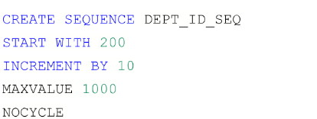

1. Write a query in a script to display the following information about your sequences: sequence name, maximum value, increment size, and last number

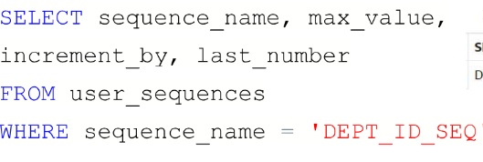

1. Write a script to insert two rows into the DEPT table. Name your script lab12_3.sql. Be sure to use the sequence that you created for the ID column. Add two departments named Education and Administration. Confirm your additions. Run the commands in your script.

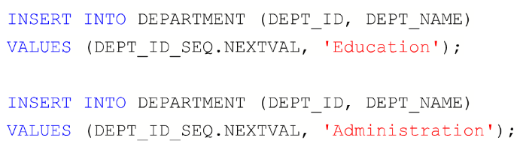

1. Create a nonunique index on the foreign key column (DEPT_ID) in the EMP table.

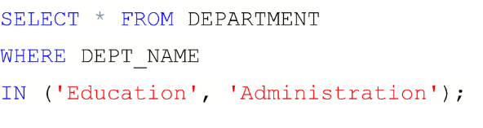

1. Display the indexes and uniqueness that exist in the data dictionary for the EMP table.

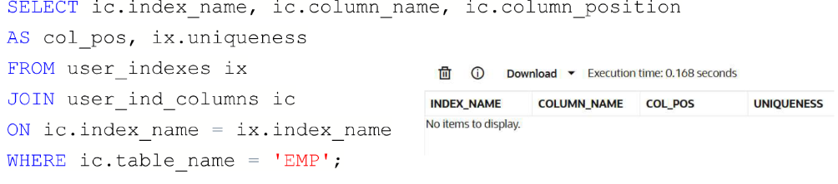

###### EXERCISE-15

###### Controlling User Access

**Objectives**

After the completion of this exercise, the students will be able to do the following:

* Create users
* Create roles to ease setup and maintenance of the security model
* Use the GRANT and REVOKE statements to grant and revoke object privileges
* Create and access database links

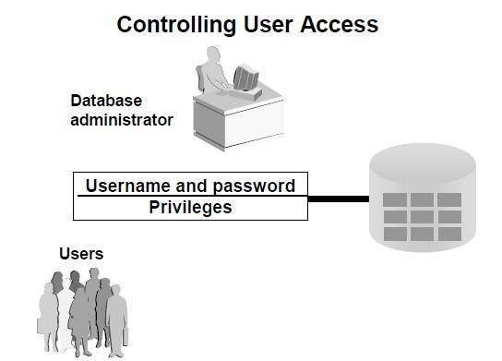

**Controlling User Access**

In a multiple-user environment, you want to maintain security of the database access and use. With Oracle server database security, you can do the following:

* Control database access
* Give access to specific objects in the database
* Confirm given and received *privileges* with the Oracle data dictionary
* Create synonyms for database objects

**Privileges**

* Database security: – System security

– Data security

* System privileges: Gaining access to the database
* Object privileges: Manipulating the content of the database objects
* Schemas: Collections of objects, such as tables, views, and sequences

**System Privileges**

* More than 100 privileges are available.
* The database administrator has high-level system privileges for tasks such as:
* Creating new users
* Removing users
* Removing tables
* Backing up tables

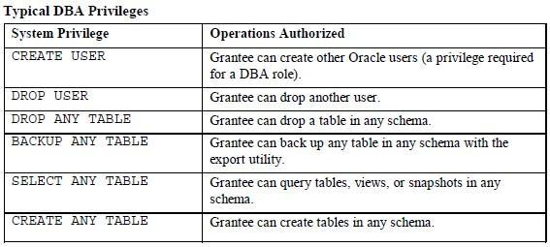

**Creating Users**

The DBA creates users by using the CREATE USER statement.

**EXAMPLE:**

CREATE USER scott IDENTIFIED BY tiger;

**User System Privileges**

* Once a user is created, the DBA can grant specific system privileges to a user.
* An application developer, for example, may have the following system privileges:
* CREATE SESSION
* CREATE TABLE
* CREATE SEQUENCE
* CREATE VIEW
* CREATE PROCEDURE

GRANT *privilege* [, *privilege*...]

TO *user* [, *user| role, PUBLIC*...];

**Typical User Privileges**

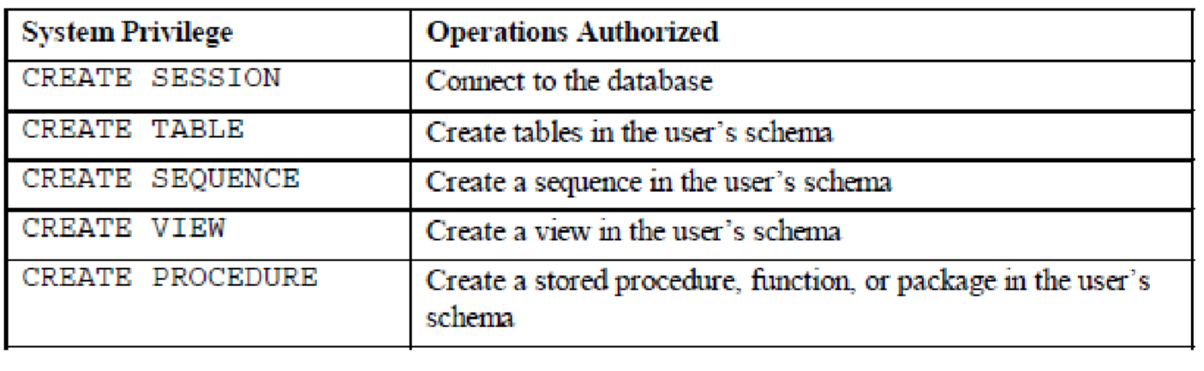**.**

**In the syntax:**

*privilege* is the system privilege to be granted

*user* |role|PUBLIC is the name of the user, the name of the role, or PUBLIC designates that every user is granted the privilege

**Note:** Current system privileges can be found in the dictionary view SESSION_PRIVS.

**Granting System Privileges**

The DBA can grant a user specific system privileges.

GRANT create session, create table, create sequence, create view TO scott;

**What is a Role?**

A role is a named group of related privileges that can be granted to the user. This method makes it easier to revoke and maintain privileges.

A user can have access to several roles, and several users can be assigned the same role. Roles are typically created for a database application.

**Creating and Assigning a Role**

First, the DBA must create the role. Then the DBA can assign privileges to the role and users to the role.

**Syntax**

CREATE ROLE *role*;

In the syntax: *role* is the name of the role to be created

Now that the role is created, the DBA can use the GRANT statement to assign users to the role as well as assign privileges to the role.

**Creating and Granting Privileges to a Role**

CREATE ROLE manager;

Role created.

GRANT create table, create view TO manager; Grant succeeded.

GRANT manager TO DEHAAN, KOCHHAR;

Grant succeeded.

* Create a role
* Grant privileges to a role
* Grant a role to users

**Changing Your Password**

* The DBA creates your user account and initializes your password.

* You can change your password by using the

ALTER USER statement.

ALTER USER scott IDENTIFIED BY lion;

User altered**.**

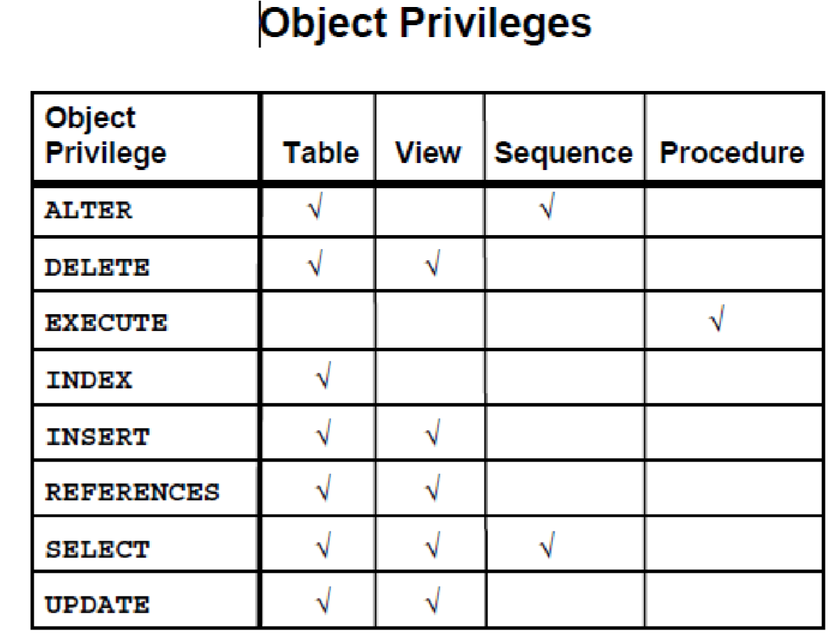

**Object Privileges**

* Object privileges vary from object to object.

* An owner has all the privileges on the object.

* An owner can give specific privileges on that owner’s object. GRANT *object_priv* [(*columns*)]

ON *object*

TO {*user*|*role*|PUBLIC}

[WITH GRANT OPTION];

**In the syntax:**

*object_priv* is an object privilege to be granted

ALL specifies all object privileges

*columns* specifies the column from a table or view on which privileges are granted

ON *object* is the object on which the privileges are granted

TO identifies to whom the privilege is granted

PUBLIC grants object privileges to all users

WITH GRANT OPTION allows the grantee to grant the object privileges to other users and roles

**Granting Object Privileges**

* Grant query privileges on the EMPLOYEES table.

* Grant privileges to update specific columns to users and roles.

GRANT select

ON employees

TO sue, rich;

GRANT update (department_name, location_id)

ON departments

TO scott, manager;

**Using the WITH GRANT OPTION and PUBLIC**

**Keywords**

* Give a user authority to pass along privileges.

* Allow all users on the system to query data from Alice’s DEPARTMENTS table.

GRANT select, insert

ON departments

TO scott

WITH GRANT OPTION;

.

GRANT select

ON alice.departments

TO PUBLIC;

**How to Revoke Object Privileges**

* You use the REVOKE statement to revoke privileges granted to other users.

* Privileges granted to others through the WITH GRANT OPTION clause are also revoked. REVOKE {privilege [, privilege...]|ALL}

ON object

FROM {user[, user...]|role|PUBLIC}

[CASCADE CONSTRAINTS];

**In the syntax:**

CASCADE is required to remove any referential integrity constraints made to the CONSTRAINTS object by means of the REFERENCES privilege

**Revoking Object Privileges**

As user Alice, revoke the SELECT and INSERT privileges given to user Scott on the DEPARTMENTS table.

REVOKE select, insert

ON departments

FROM scott;

**Find the Solution for the following:**

1. What privilege should a user be given to log on to the Oracle Server? Is this a system or an object privilege?



_____________________________________________________________________

1. What privilege should a user be given to create tables?



_____________________________________________________________________

1. If you create a table, who can pass along privileges to other users on your table?

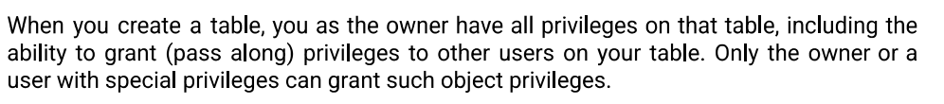

_____________________________________________________________________

1. You are the DBA. You are creating many users who require the same system privileges. What should you use to make your job easier?

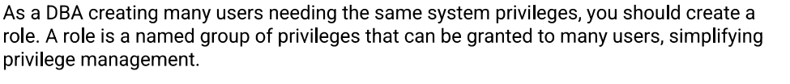

_____________________________________________________________________

1. What command do you use to change your password?



_____________________________________________________________________

1. Grant another user access to your DEPARTMENTS table. Have the user grant you query access to his or her DEPARTMENTS table.

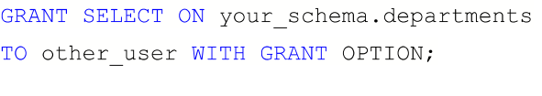

1. Query all the rows in your DEPARTMENTS table.

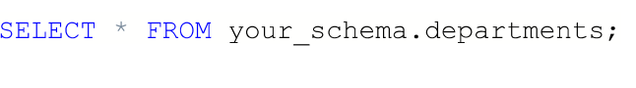

1. Add a new row to your DEPARTMENTS table. Team 1 should add Education as department number 500. Team 2 should add Human Resources department number 510. Query the other team’s table.

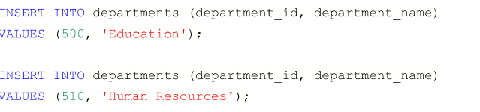

1. Query the USER_TABLES data dictionary to see information about the tables that you own.

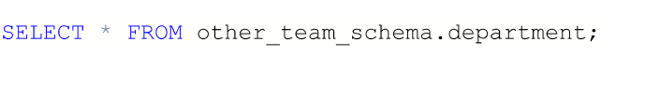

1. Revoke the SELECT privilege on your table from the other team.

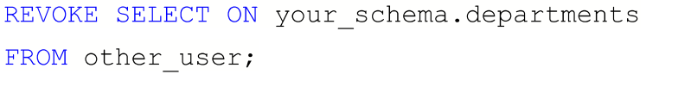

| Evaluation Procedure | Marks awarded |
| --- | --- |
| Practice Evaluation (5) |  |
| Viva(5) |  |
| Total (10) |  |
| Faculty Signature |  |

PL/SQL

###### PL/SQL

###### Control Structures

In addition to SQL commands,PL/SQL can also process data usin flow of statements.the flow of control statements are classified into the following categories.

* Conditional control -Branching
* Iterative control - looping ● Sequential control

**BRANCHING in PL/SQL:**

Sequence of statements can be executed on satisfying certain condition .

If statements are being used and different forms of if are:

1.Simple IF

2.ELSIF

3.ELSE IF ***SIMPLE IF:***

**Syntax:**

IF condition THEN

statement1; statement2;

END IF;

***IF-THEN-ELSE STATEMENT:***

**Syntax:**

IF condition THEN statement1;

ELSE

statement2;

END IF;

***ELSIF STATEMENTS:***

**Syntax:**

IF condition1 THEN

statement1;

ELSIF condition2 THEN

statement2;

ELSIF condition3 THEN

statement3;

ELSE

statementn;

END IF;

***NESTED IF :***

**Syntax:** IF condition THEN

statement1;

ELSE

IF condition THEN

statement2; ELSE

statement3; END IF;

END IF; ELSE

statement3;

END IF;

**SELECTION IN PL/SQL(Sequential Controls)**

***SIMPLE CASE***

**Syntax:**

CASE SELECTOR

WHEN Expr1 THEN statement1; WHEN Expr2 THEN statement2;

:

ELSE

Statement n;

END CASE;

***SEARCHED CASE:***

CASE

WHEN searchcondition1 THEN statement1; WHEN searchcondition2 THEN statement2;

:

:

ELSE

statementn;

END CASE;

**ITERATIONS IN PL/SQL**

Sequence of statements can be executed any number of times using loop construct.

It is broadly classified into:

* Simple Loop
* For Loop
* While Loop

***SIMPLE LOOP***

**Syntax:** LOOP

statement1;

EXIT [ WHEN Condition];

END LOOP; ***WHILE LOOP***

**Syntax:**

WHILE condition LOOP

statement1; statement2;

END LOOP;

***FOR LOOP***

**Syntax:**

FOR counter IN [REVERSE]

LowerBound..UpperBound LOOP

statement1; statement2;

END LOOP;

Write a PL/SQL block to calculate the incentive of an employee whose ID is 110.

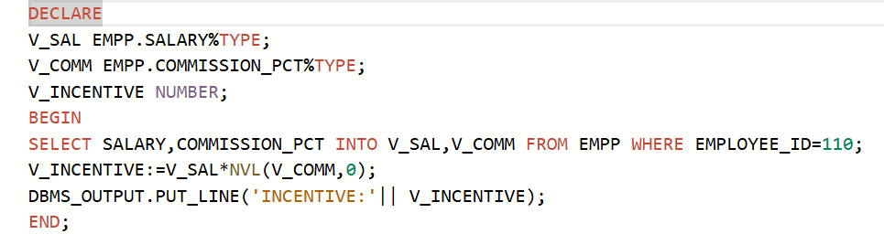

Write a PL/SQL block to show an invalid case-insensitive reference to a quoted and without quoted user-defined identifier.

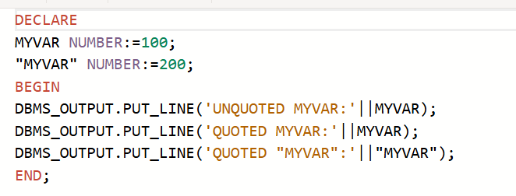

Write a PL/SQL block to adjust the salary of the employee whose ID 122.

Sample table: employees

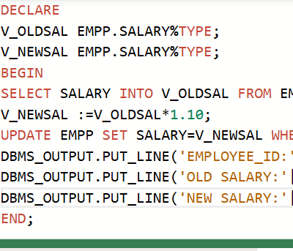

Write a PL/SQL block to create a procedure using the "IS [NOT] NULL Operator" and show AND operator returns TRUE if and only if both operands are TRUE.

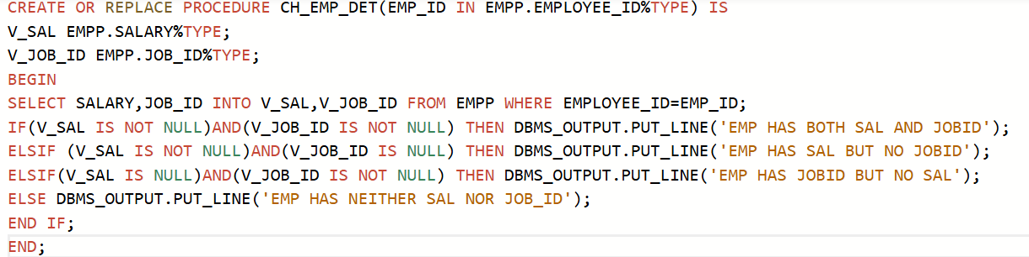

Write a PL/SQL block to describe the usage of LIKE operator including wildcard characters and escape character.

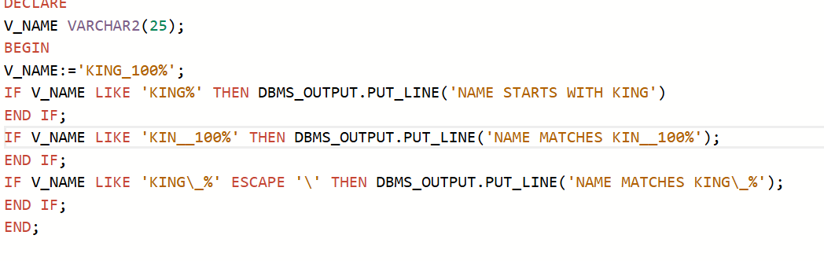

PROGRAM 6

Write a PL/SQL program to arrange the number of two variable in such a way that the small number will store in num_small variable and large number will store in num_large variable.

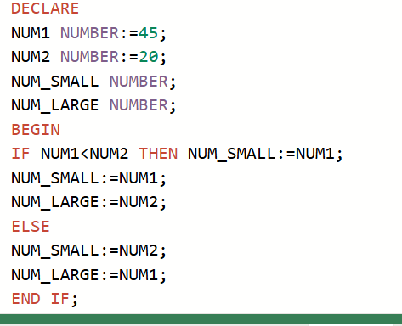

PROGRAM 7

Write a PL/SQL procedure to calculate the incentive on a target achieved and display the message either the record updated or not.

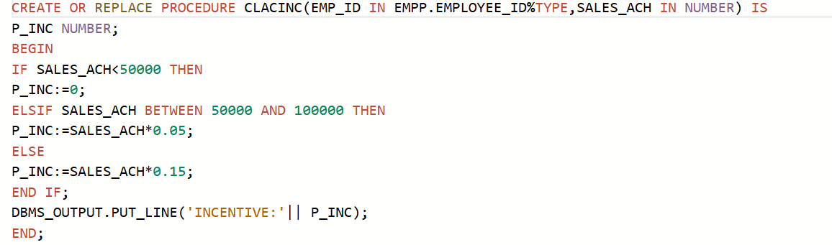

PROGRAM 8

Write a PL/SQL procedure to calculate incentive achieved according to the specific sale limit.

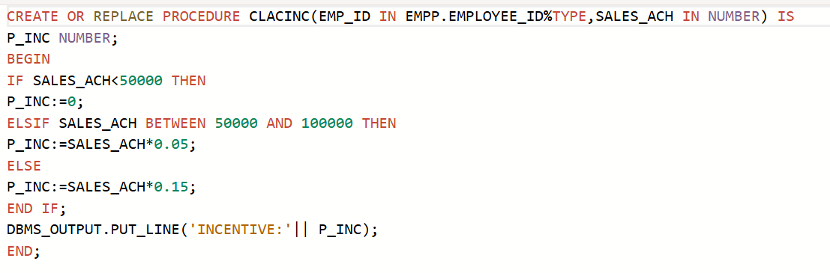

PROGRAM 9

Write a PL/SQL program to count number of employees in department 50 and check whether this department have any vacancies or not. There are 45 vacancies in this department.

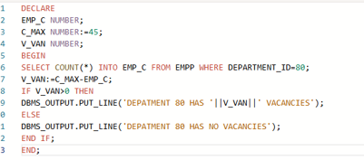

PROGRAM 10

Write a PL/SQL program to count number of employees in a specific department and check whether this department have any vacancies or not. If any vacancies, how many vacancies are in that department.

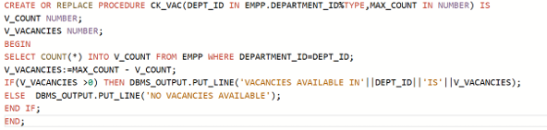

PROGRAM 11

Write a PL/SQL program to display the employee IDs, names, job titles, hire dates, and salaries of all employees.



Write a PL/SQL program to display the employee IDs, names, and department names of all employees.

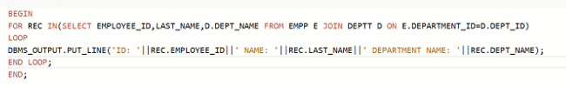

Write a PL/SQL program to display the job IDs, titles, and minimum salaries of all jobs. 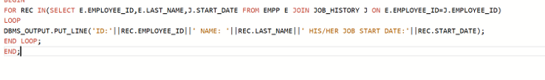

Write a PL/SQL program to display the employee IDs, names, and job history start dates of all employees.

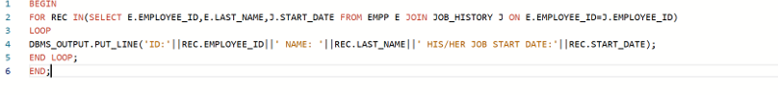

PROGRAM 15

Write a PL/SQL program to display the employee IDs, names, and job history end dates of all employees.

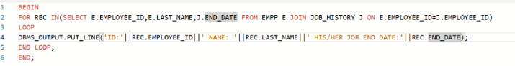

| **Evaluation Procedure** | **Marks awarded** |
| --- | --- |
| **PL/SQL**  **Procedure(5)** |  |
| **Program/Execution**  **(5)** |  |
| **Viva(5)** |  |
| **Total (15)** |  |
| **Faculty Signature** |  |

###### EXERCISE-16

###### PROCEDURES AND FUNCTIONS

**PROCEDURES**

**DEFINITION**

A procedure or function is a logically grouped set of SQL and PL/SQL statements that perform a specific task. They are essentially sub-programs. Procedures and functions are made up of,

* Declarative part
* Executable part
* Optional exception handling part

These procedures and functions do not show the errors.

**KEYWORDS AND THEIR PURPOSES**



**REPLACE:** It recreates the procedure if it already exists.

**PROCEDURE:** It is the name of the procedure to be created.

**ARGUMENT:** It is the name of the argument to the procedure. Paranthesis can be omitted if no arguments are present.

**IN:** Specifies that a value for the argument must be specified when calling the procedure ie . used to pass values to a sub-program. This is the default parameter.

**OUT:**  Specifies that the procedure passes a value for this argument back to it’s calling environment after execution ie. used to return values to a caller of the sub-program.

**INOUT:** Specifies that a value for the argument must be specified when calling the procedure and

that procedure passes a value for this argument back to it’s calling environment after execution.

**RETURN:** It is the datatype of the function’s return value because eve ry function must return a value, this clause is required.

**PROCEDURES – SYNTAX**

create or replace procedure <procedure name> (argument {in,out,inout} datatype ) {is,as} variable declaration; constant declaration; begin

PL/SQL subprogram body;

exception

exception PL/SQL block;

end;

**FUNCTIONS – SYNTAX**



create or replace function <function name> (argument in datatype,……) return datatype {is,as}

variable declaration;

constant declaration; begin

PL/SQL subprogram body; exception

exception PL/SQL block;

end;

**CREATING THE TABLE ‘ITITEMS’ AND DISPLAYING THE CONTENTS**

SQL> create table ititems(itemid number(3), actualprice number(5), ordid number(4), prodid number(4)); Table created.

SQL> insert into ititems values(101, 2000, 500, 201); 1 row created.

SQL> insert into ititems values(102, 3000, 1600, 202); 1 row created.

SQL> insert into ititems values(103, 4000, 600, 202); 1 row created.

SQL> select * from ititems;

ITEMID ACTUALPRICE ORDID PRODID

--------- ----------- -------- --------- 101 2000 500 201

1. 3000 1600 202
2. 4000 600 202

**PROGRAM FOR GENERAL PROCEDURE – SELECTED RECORD’S PRICE IS INCREMENTED BY 500 , EXECUTING THE PROCEDURE CREATED AND**

**DISPLAYING THE UPDATED TABLE**

SQL> create procedure itsum(identity number, total number) is price number;

1. null_price exception;
2. begin
3. select actualprice into price from ititems where itemid=identity;
4. if price is null then
5. raise null_price;
6. else
7. update ititems set actualprice=actualprice+total where itemid=identity; 9 end if;
8. exception
9. when null_price then
10. dbms_output.put_line('price is null');
11. end; 14 /

Procedure created.

SQL> exec itsum(101, 500);

PL/SQL procedure successfully completed.

SQL> select * from ititems;

ITEMID ACTUALPRICE ORDID PRODID

--------- ----------- --------- ---------

* 1. 2500 500 201
  2. 3000 1600 202
  3. 4000 600 202

**PROCEDURE FOR ‘IN’ PARAMETER – CREATION, EXECUTION**

SQL> set serveroutput on;

SQL> create procedure yyy (a IN number) is price number; 2 begin

1. select actualprice into price from ititems where itemid=a;
2. dbms_output.put_line('Actual price is ' || price);
3. if price is null then
4. dbms_output.put_line('price is null');
5. end if;
6. end; 9 /

Procedure created.

SQL> exec yyy(103);

Actual price is 4000

PL/SQL procedure successfully completed.

**PROCEDURE FOR ‘OUT’ PARAMETER – CREATION, EXECUTION**



SQL> set serveroutput on;

SQL> create procedure zzz (a in number, b out number) is identity number; 2 begin

1. select ordid into identity from ititems where itemid=a;
2. if identity<1000 then
3. b:=100;
4. end if;
5. end; 8 /

Procedure created.

SQL> declare

1. a number;
2. b number;
3. begin
4. zzz(101,b);
5. dbms_output.put_line('The value of b is '|| b);
6. end;
7. /

The value of b is 100

PL/SQL procedure successfully completed.

**PROCEDURE FOR ‘INOUT’ PARAMETER – CREATION, EXECUTION**

SQL> create procedure itit ( a in out number) is

1. begin
2. a:=a+1;
3. end; 5 /

Procedure created.

SQL> declare

1. a number:=7;
2. begin
3. itit(a);
4. dbms_output.put_line(‘The updated value is ‘||a);
5. end;
6. /

The updated value is 8

PL/SQL procedure successfully completed.

**CREATE THE TABLE ‘ITTRAIN’ TO BE USED FOR FUNCTIONS**



SQL>create table ittrain ( tno number(10), tfare number(10)); Table created.

SQL>insert into ittrain values (1001, 550); 1 row created.

SQL>insert into ittrain values (1002, 600); 1 row created.

SQL>select * from ittrain;

TNO TFARE

--------- ------------

1. 550
2. 600

**PROGRAM FOR FUNCTION AND IT’S EXECUTION**

SQL> create function aaa (trainnumber number) return number is

1. trainfunction ittrain.tfare % type;
2. begin
3. select tfare into trainfunction from ittrain where tno=trainnumber;
4. return(trainfunction);
5. end;
6. /

Function created.

SQL> set serveroutput on;

SQL> declare

1. total number;
2. begin
3. total:=aaa (1001);
4. dbms_output.put_line('Train fare is Rs. '||total);
5. end;
6. /

Train fare is Rs.550

PL/SQL procedure successfully completed.

###### Program 1

**FACTORIAL OF A NUMBER USING FUNCTION**

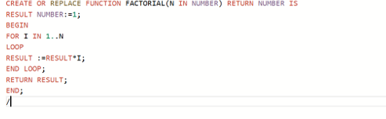

Program 2

**Write a PL/SQL program using Procedures IN,INOUT,OUT parameters to retrieve the corresponding book information in library**

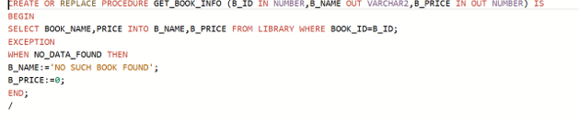

| **Evaluation Procedure** | **Marks awarded** |
| --- | --- |
| **PL/SQL**  **Procedure(5)** |  |
| **Program/Execution**  **(5)** |  |
| **Viva(5)** |  |
| **Total (15)** |  |
| **Faculty Signature** |  |

###### EXERCISE-17

###### TRIGGER

**DEFINITION**

A trigger is a statement that is executed automatically by the system as a side effect of a modification to the database. The parts of a trigger are,

* **Trigger statement**: Specifies the DML statements and fires the trigger body. It also specifies the table to which the trigger is associated.

* **Trigger body or trigger action**: It is a PL/SQL block that is executed when the triggering statement is used.

* **Trigger restriction**: Restrictions on the trigger can be achieved

**The different uses of triggers are as follows,**

* *To generate data automatically*
* *To enforce complex integrity constraints*
* *To customize complex securing authorizations*
* *To maintain the replicate table*
* To audit data modifications

**TYPES OF TRIGGERS**



The various types of triggers are as follows,

* **Before**: It fires the trigger before executing the trigger statement.

* **After**: It fires the trigger after executing the trigger statement
* .
* **For each row**: It specifies that the trigger fires once per row
* .
* **For each statement**: This is the default trigger that is invoked. It specifies that the trigger fires once per statement.

**VARIABLES USED IN TRIGGERS**

* :new

* :old

These two variables retain the new and old values of the column updated in the database. The values in these variables can be used in the database triggers for data manipulation

**SYNTAX**



create or replace trigger triggername [before/after] {DML statements} on [tablename] [for each row/statement] begin

-------------------------

-------------------------

------------------------- exception end;

**USER DEFINED ERROR MESSAGE**

The package “raise_application_error” is used to issue the user defined error messages

**Syntax:** raise_application_error(error number,‘error message‘);

The error number can lie between -20000 and -20999.

The error message should be a character string.

**TO CREATE THE TABLE ‘ITEMPLS’**

SQL> create table itempls (ename varchar2(10), eid number(5), salary number(10)); Table created.

SQL> insert into itempls values('xxx',11,10000); 1 row created.

SQL> insert into itempls values('yyy',12,10500); 1 row created.

SQL> insert into itempls values('zzz',13,15500); 1 row created.

SQL> select * from itempls;

ENAME EID SALARY

---------- --------- --------- xxx 11 10000 yyy 12 10500

zzz 13 15500

**TO CREATE A SIMPLE TRIGGER THAT DOES NOT ALLOW INSERT UPDATE AND**

**DELETE OPERATIONS ON THE TABLE**

SQL> create trigger ittrigg before insert or update or delete on itempls for each row 2 begin

1. raise_application_error(-20010,'You cannot do manipulation');
2. end;

5

6 /

Trigger created.

SQL> insert into itempls values('aaa',14,34000);

insert into itempls values('aaa',14,34000)

ERROR at line 1:

ORA-20010: You cannot do manipulation

ORA-06512: at "STUDENT.ITTRIGG", line 2

ORA-04088: error during execution of trigger 'STUDENT.ITTRIGG'

SQL> delete from itempls where ename='xxx';

delete from itempls where ename='xxx'

ERROR at line 1:

ORA-20010: You cannot do manipulation

ORA-06512: at "STUDENT.ITTRIGG", line 2

ORA-04088: error during execution of trigger 'STUDENT.ITTRIGG'

SQL> update itempls set eid=15 where ename='yyy'; update itempls set eid=15 where ename='yyy'

ERROR at line 1:

ORA-20010: You cannot do manipulation

ORA-06512: at "STUDENT.ITTRIGG", line 2

ORA-04088: error during execution of trigger 'STUDENT.ITTRIGG'

**TO DROP THE CREATED TRIGGER**

SQL> drop trigger ittrigg;

Trigger dropped.

**TO CREATE A TRIGGER THAT RAISES AN USER DEFINED ERROR MESSAGE AND**

**DOES NOT ALLOW UPDATION AND INSERTION**

SQL> create trigger ittriggs before insert or update of salary on itempls for each row 2 declare

1. triggsal itempls.salary%type;
2. begin
3. select salary into triggsal from itempls where eid=12;
4. if(:new.salary>triggsal or :new.salary<triggsal) then
5. raise_application_error(-20100,'Salary has not been changed'); 8 end if;
6. end;
7. /

Trigger created.

SQL> insert into itempls values ('bbb',16,45000);

insert into itempls values ('bbb',16,45000)

ERROR at line 1:

ORA-04098: trigger 'STUDENT.ITTRIGGS' is invalid and failed re-validation

SQL> update itempls set eid=18 where ename='zzz'; update itempls set eid=18 where ename='zzz'

ERROR at line 1:

ORA-04298: trigger 'STUDENT.ITTRIGGS' is invalid and failed re-validation

Cursor for loop

 Explicit cursor

 Implicit cursor

**TO CREATE THE TABLE ‘SSEMPP’**

SQL> create table ssempp( eid number(10), ename varchar2(20), job varchar2(20), sal number

(10),dnonumber(5)); Table created.

SQL> insert into ssempp values(1,'nala','lecturer',34000,11); 1 row created.

SQL> insert into ssempp values(2,'kala',' seniorlecturer',20000,12); 1 row created.

SQL> insert into ssempp values(5,'ajay','lecturer',30000,11); 1 row created.

SQL> insert into ssempp values(6,'vijay','lecturer',18000,11); 1 row created.

SQL> insert into ssempp values(3,'nila','professor',60000,12); 1 row created.

SQL> select * from ssempp;

EID ENAME JOB SAL DNO

--------- -------------------- -------------------- --------- --------- 1 nala lecturer 34000 11

2 kala seniorlecturer 20000 12

1. ajay lecturer 30000 11
2. vijay lecturer 18000 11 3 nila professor 60000 12

**EXTRA PROGRAMS**

**TO WRITE A PL/SQL BLOCK TO DISPLAY THE EMPOYEE ID AND EMPLOYEE**

**NAME USING CURSOR FOR LOOP**

SQL> set serveroutput on;

SQL> declare

1. begin
2. for emy in (select eid,ename from ssempp)
3. loop
4. dbms_output.put_line('Employee id and employee name are '|| emy.eid ‘and’|| emy.ename); 6 end loop;
5. end;
6. /

Employee id and employee name are 1 and nala

Employee id and employee name are 2 and kala

Employee id and employee name are 5 and ajay

Employee id and employee name are 6 and vijay

Employee id and employee name are 3 and nila

PL/SQL procedure successfully completed.

**TO WRITE A PL/SQL BLOCK TO UPDATE THE SALARY OF ALL**

**EMPLOYEES WHERE DEPARTMENT NO IS 11 BY 5000 USING CURSOR FOR LOOP**

**AND TO DISPLAY THE UPDATED TABLE**

SQL> set serveroutput on;

SQL> declare

2 cursor cem is select eid,ename,sal,dno from ssempp where dno=11; 3 begin

1. --open cem;
2. for rem in cem
3. loop
4. update ssempp set sal=rem.sal+5000 where eid=rem.eid;
5. end loop;
6. --close cem;
7. end;
8. /

PL/SQL procedure successfully completed.

SQL> select * from ssempp;

EID ENAME JOB SAL DNO --------- -------------------- -------------------- --------- ---------

* 1. nala lecturer 39000 11
  2. kala seniorlecturer 20000 12
  3. ajay lecturer 35000 11
  4. vijay lecturer 23000 11 3 nila professor 60000 12

**TO WRITE A PL/SQL BLOCK TO DISPLAY THE EMPLOYEE ID AND EMPLOYEE**

**NAME WHERE DEPARTMENT NUMBER IS 11 USING EXPLICIT CURSORS**

1. declare
2. cursor cenl is select eid,sal from ssempp where dno=11;
3. ecode ssempp.eid%type;
4. esal empp.sal%type;
5. begin
6. open cenl;
7. loop
8. fetch cenl into ecode,esal;
9. exit when cenl%notfound;
10. dbms_output.put_line(' Employee code and employee salary are' || ecode ‘and’|| esal); 11 end loop;

12 close cenl;

13* end;

SQL> /

Employee code and employee salary are 1 and 39000

Employee code and employee salary are 5 and 35000

Employee code and employee salary are 6 and 23000

PL/SQL procedure successfully completed.

**TO WRITE A PL/SQL BLOCK TO UPDATE THE SALARY BY 5000 WHERE THE JOB IS LECTURER , TO CHECK IF UPDATES ARE MADE USING IMPLICIT CURSORS AND**

**TO DISPLAY THE UPDATED TABLE**

SQL> declare

1. county number;
2. begin
3. update ssempp set sal=sal+10000 where job='lecturer';
4. county:= sql%rowcount;
5. if county > 0 then
6. dbms_output.put_line('The number of rows are '|| county); 8 end if;
7. if sql %found then
8. dbms_output.put_line('Employee record modification successful');
9. else if sql%notfound then
10. dbms_output.put_line('Employee record is not found');
11. end if;
12. end if;
13. end;
14. /

The number of rows are 3

Employee record modification successful

PL/SQL procedure successfully completed.

SQL> select * from ssempp;

EID ENAME JOB SAL DNO --------- -------------------- -------------------- --------- --------- 1 nala lecturer 44000 11

* 1. kala seniorlecturer 20000 12
  2. ajay lecturer 40000 11
  3. vijay lecturer 28000 11
  4. nila professor 60000 12

**PROGRAMS**

**TO DISPLAY HELLO MESSAGE**

SQL> set serveroutput on;

SQL> declare

1. a varchar2(20);
2. begin
3. a:='Hello';
4. dbms_output.put_line(a);
5. end;
6. /

Hello

PL/SQL procedure successfully completed.

**TO INPUT A VALUE FROM THE USER AND DISPLAY IT**

SQL> set serveroutput on;

SQL> declare

1. a varchar2(20);
2. begin
3. a:=&a;
4. dbms_output.put_line(a);
5. end;
6. /

Enter value for a: 5 old 4: a:=&a; new 4: a:=5;

5

PL/SQL procedure successfully completed.

**GREATEST OF TWO NUMBERS**

SQL> set serveroutput on;

SQL> declare

2 a number(7); 3 b number(7);

1. begin
2. a:=&a;
3. b:=&b;
4. if(a>b) then
5. dbms_output.put_line (' The grerater of the two is'|| a);
6. else
7. dbms_output.put_line (' The grerater of the two is'|| b);
8. end if;
9. end;
10. /

Enter value for a: 5 old 5: a:=&a; new 5: a:=5; Enter value for b: 9 old 6: b:=&b; new 6: b:=9; The grerater of the two is9

PL/SQL procedure successfully completed.

**GREATEST OF THREE NUMBERS**



SQL> set serveroutput on;

SQL> declare

2 a number(7); 3 b number(7); 4 c number(7);

1. begin
2. a:=&a;
3. b:=&b;
4. c:=&c;
5. if(a>b and a>c) then
6. dbms_output.put_line (' The greatest of the three is ' || a);
7. else if (b>c) then
8. dbms_output.put_line (' The greatest of the three is ' || b);
9. else
10. dbms_output.put_line (' The greatest of the three is ' || c);
11. end if;
12. end if;
13. end;
14. /

Enter value for a: 5 old 6: a:=&a; new 6: a:=5; Enter value for b: 7 old 7: b:=&b; new 7: b:=7; Enter value for c: 1 old 8: c:=&c; new 8: c:=1;

The greatest of the three is 7

PL/SQL procedure successfully completed.

**PRINT NUMBERS FROM 1 TO 5 USING SIMPLE LOOP** 

SQL> set serveroutput on;

SQL> declare

1. a number:=1;
2. begin
3. loop
4. dbms_output.put_line (a);
5. a:=a+1;
6. exit when a>5;
7. end loop;
8. end;
9. /

1

2

3

4

5

PL/SQL procedure successfully completed.

**PRINT NUMBERS FROM 1 TO 4 USING WHILE LOOP**

SQL> set serveroutput on;

SQL> declare

1. a number:=1;
2. begin
3. while(a<5)
4. loop
5. dbms_output.put_line (a);
6. a:=a+1;
7. end loop;
8. end;
9. /

1

2

3

4

PL/SQL procedure successfully completed.

**PRINT NUMBERS FROM 1 TO 5 USING FOR LOOP** 

SQL> declare

1. a number:=1;
2. begin
3. for a in 1..5
4. loop
5. dbms_output.put_line (a);
6. end loop;
7. end;
8. /

1

2

3

4

5

PL/SQL procedure successfully completed.

**PRINT NUMBERS FROM 1 TO 5 IN REVERSE ORDER USING FOR LOOP**  

SQL> declare

1. a number:=1;
2. begin
3. for a in reverse 1..5
4. loop
5. dbms_output.put_line (a);
6. end loop;
7. end;
8. /

5

4

3

2

1

PL/SQL procedure successfully completed.

**TO CALCULATE AREA OF CIRCLE**

SQL> set serveroutput on;

SQL> declare

1. pi constant number(4,2):=3.14;
2. a number(20);
3. r number(20);
4. begin
5. r:=&r;
6. a:= pi* power(r,2);
7. dbms_output.put_line (' The area of circle is ' || a);
8. end;
9. /

Enter value for r: 2 old 6: r:=&r; new 6: r:=2;

The area of circle is 13

PL/SQL procedure successfully completed.

**TO CREATE SACCOUNT TABLE** 

SQL> create table saccount ( accno number(5), name varchar2(20), bal number(10)); Table created.

SQL> insert into saccount values ( 1,'mala',20000); 1 row created.

SQL> insert into saccount values (2,'kala',30000); 1 row created.

SQL> select * from saccount;

ACCNO NAME BAL

--------- -------------------- ---------

1. mala 20000
2. kala 30000

SQL> set serveroutput on;

SQL> declare

1. a_bal number(7);
2. a_no varchar2(20);
3. debit number(7):=2000;
4. minamt number(7):=500;
5. begin
6. a_no:=&a_no;
7. select bal into a_bal from saccount where accno= a_no;
8. a_bal:= a_bal-debit;
9. if (a_bal > minamt) then
10. update saccount set bal=bal-debit where accno=a_no;
11. end if;
12. end;

14

15 /

Enter value for a_no: 1 old 7: a_no:=&a_no; new 7: a_no:=1;

PL/SQL procedure successfully completed.

SQL> select * from saccount;

ACCNO NAME BAL

--------- -------------------- ---------

1. mala 18000
2. kala 30000

**TO CREATE TABLE SROUTES**

SQL> create table sroutes ( rno number(5), origin varchar2(20), destination varchar2(20), fare numbe

r(10), distance number(10)); Table created.

SQL> insert into sroutes values ( 2, 'chennai', 'dindugal', 400,230); 1 row created.

SQL> insert into sroutes values ( 3, 'chennai', 'madurai', 250,300); 1 row created.

SQL> insert into sroutes values ( 6, 'thanjavur', 'palani', 350,370); 1 row created.

SQL> select * from sroutes;

RNO ORIGIN DESTINATION FARE DISTANCE

--------- -------------------- -------------------- --------- ---------

2 chennai dindugal 400 230 3 chennai madurai 250 300

6 thanjavur palani 350 370

SQL> set serveroutput on;

SQL> declare

1. route sroutes.rno % type;
2. fares sroutes.fare % type;
3. dist sroutes.distance % type;
4. begin
5. route:=&route;
6. select fare, distance into fares , dist from sroutes where rno=route;
7. if (dist < 250) then
8. update sroutes set fare=300 where rno=route;
9. else if dist between 250 and 370 then
10. update sroutes set fare=400 where rno=route;
11. else if (dist > 400) then
12. dbms_output.put_line('Sorry');
13. end if;
14. end if;
15. end if;
16. end;
17. /

Enter value for route: 3 old 6: route:=&route;

new 6: route:=3;

PL/SQL procedure successfully completed.

SQL> select * from sroutes;

RNO ORIGIN DESTINATION FARE DISTANCE

--------- -------------------- -------------------- --------- ---------

2 chennai dindugal 400 230 3 chennai madurai 400 300

6 thanjavur palani 350 370

**TO CREATE SCA LCULATE TABLE**

SQL> create table scalculate ( radius number(3), area number(5,2)); Table created. 

SQL> desc scalculate;

Name Null? Type ----------------------------------------------------- -------- ------------------------------------

RADIUS NUMBER(3)

AREA NUMBER(5,2)

SQL> set serveroutput on;

SQL> declare

1. pi constant number(4,2):=3.14;
2. area number(5,2);
3. radius number(3);
4. begin
5. radius:=3;
6. while (radius <=7)
7. loop
8. area:= pi* power(radius,2);
9. insert into scalculate values (radius,area);
10. radius:=radius+1;
11. end loop;
12. end;
13. /

PL/SQL procedure successfully completed.

SQL> select * from scalculate;

RADIUS AREA

--------- ---------

* 1. 28.26
  2. 50.24
  3. 78.5
  4. 113.04
  5. 153.86

**TO CALCULATE FACTORIAL OF A GIVEN NUMBER** 

SQL> declare

1. f number(4):=1;
2. i number(4);
3. begin
4. i:=&i;
5. while(i>=1)
6. loop
7. f:=f*i;
8. i:=i-1;
9. end loop;
10. dbms_output.put_line('The value is ' || f);
11. end;
12. /

Enter value for i: 5 old 5: i:=&i; new 5: i:=5; The value is 120

PL/SQL procedure successfully completed.

Program 1

Write a code in PL/SQL to develop a trigger that enforces referential integrity by preventing the deletion of a parent record if child records exist.

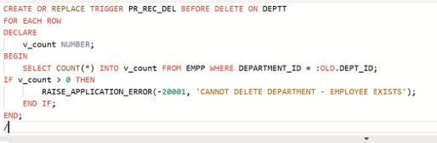

Write a code in PL/SQL to create a trigger that checks for duplicate values in a specific column and raises an exception if found.

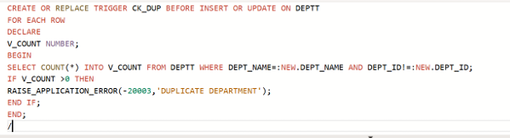

Write a code in PL/SQL to create a trigger that restricts the insertion of new rows if the total of a column's values exceeds a certain threshold.

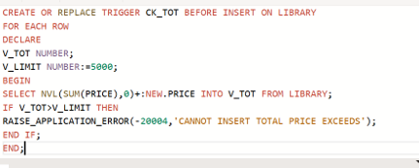

Write a code in PL/SQL to design a trigger that captures changes made to specific columns and logs them in an audit table.

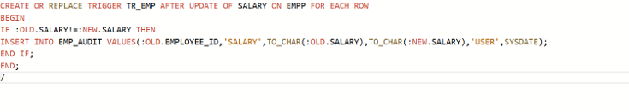

Program 5

Write a code in PL/SQL to implement a trigger that records user activity (inserts, updates, deletes) in an audit log for a given set of tables.

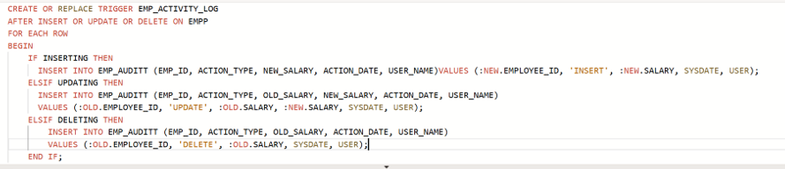

Program 7

Write a code in PL/SQL to implement a trigger that automatically calculates and updates a running total column for a table whenever new rows are inserted.

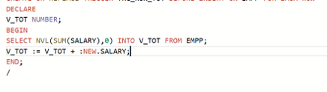

Program 8

Write a code in PL/SQL to create a trigger that validates the availability of items before allowing an order to be placed, considering stock levels and pending orders.

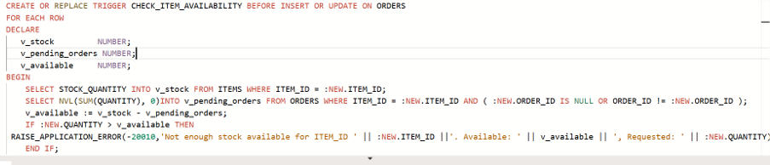

| **Evaluation Procedure** | **Marks awarded** |
| --- | --- |
| **PL/SQL**  **Procedure(5)** |  |
| **Program/Execution**  **(5)** |  |
| **Viva(5)** |  |
| **Total (15)** |  |
| **Faculty Signature** |  |